|  |  |
| --- | --- |
| **Department** |  |
| **Responsibility/Role** |  |
| **File Name** | 54e851c4-3d77-46ec-be82-a6c4f7e4fc1a_SPD |
| **Revision** |  |
| **Document Generation Date** | 9/16/2016 3:21:00 PM |
| **Date Modified** | 9/16/2016 3:21:00 PM |
| **Last Changed by** |  |
| **Status** |  |

## Regular Request Member Submission

**Trigger:**

|  |  |
| --- | --- |
| **Required Field(s)** | **Comments** |
|  |  |

|  |  |
| --- | --- |
| **Output - Result(s)** | **Comments** |
|  |  |

**Additional Information**

Procedure

This training topic will show the process a member will use to submit a Regular Request using the Retirements/Separations Component.

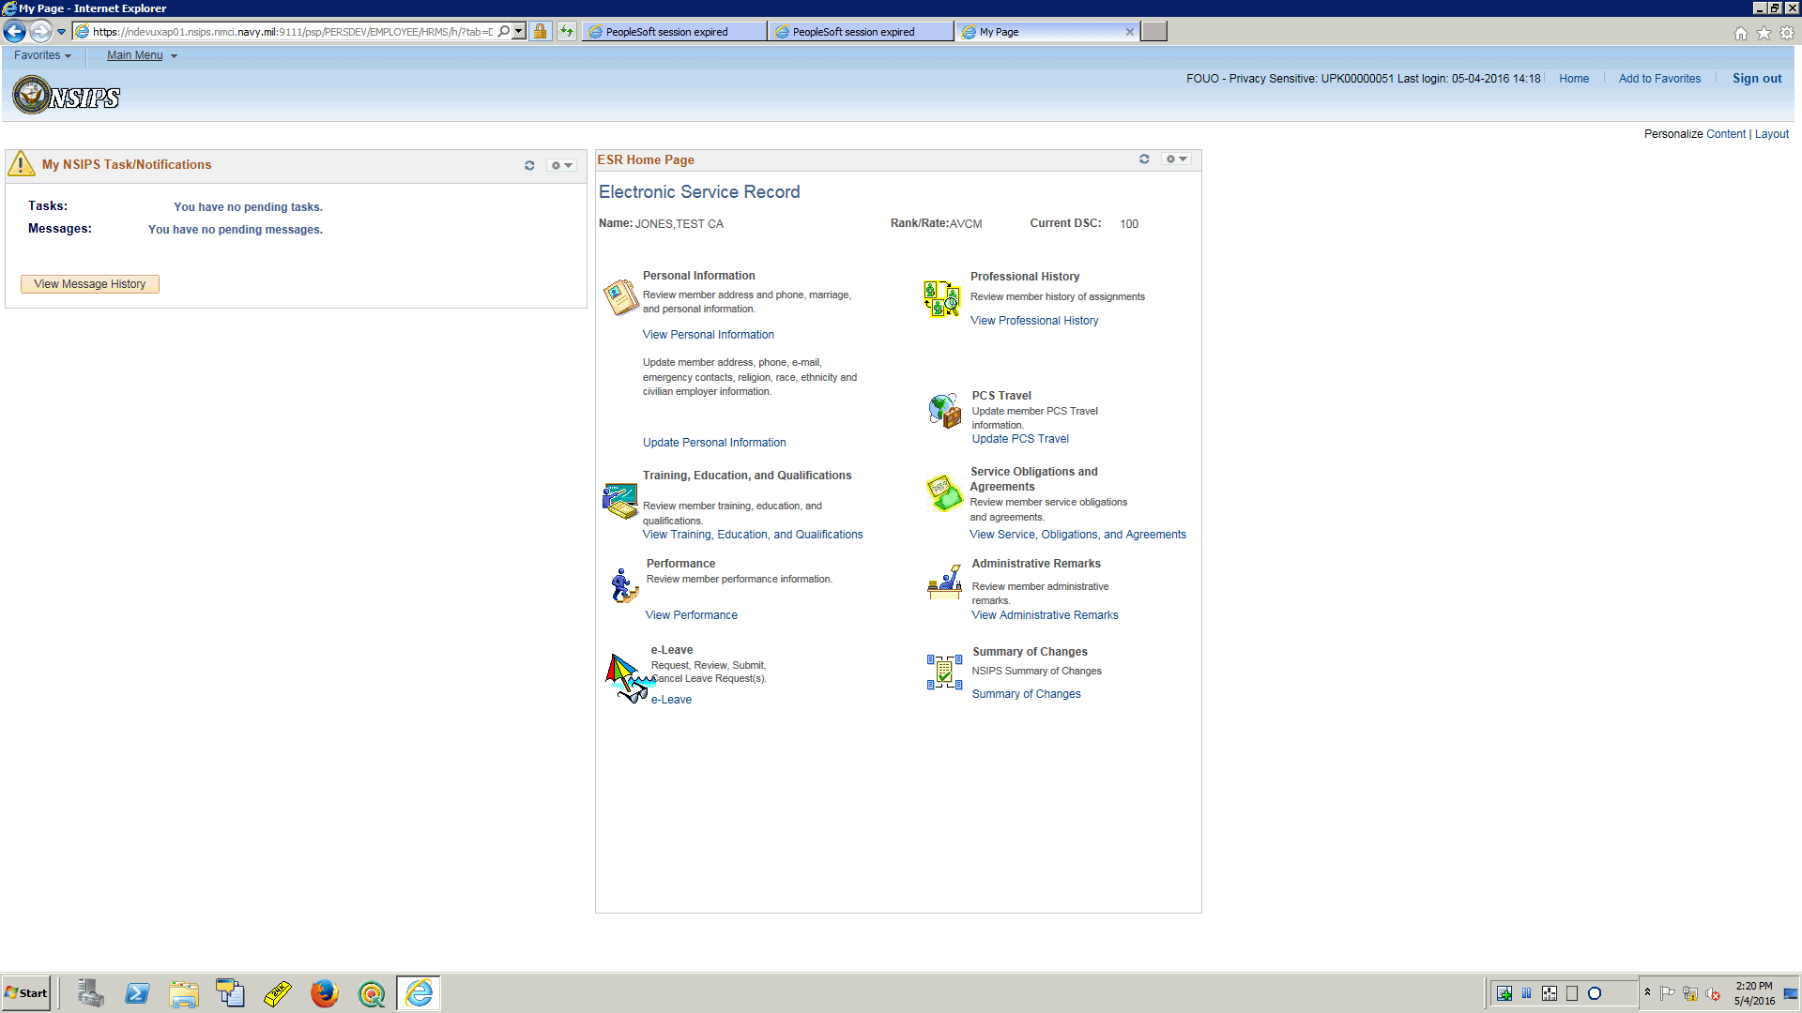

| **Step** | **Action** |
| --- | --- |
|  | The Service Member will log into NSIPS using their Self Service account.  Once logged in the navigations is as follows:  Click the **Main Menu** button. |

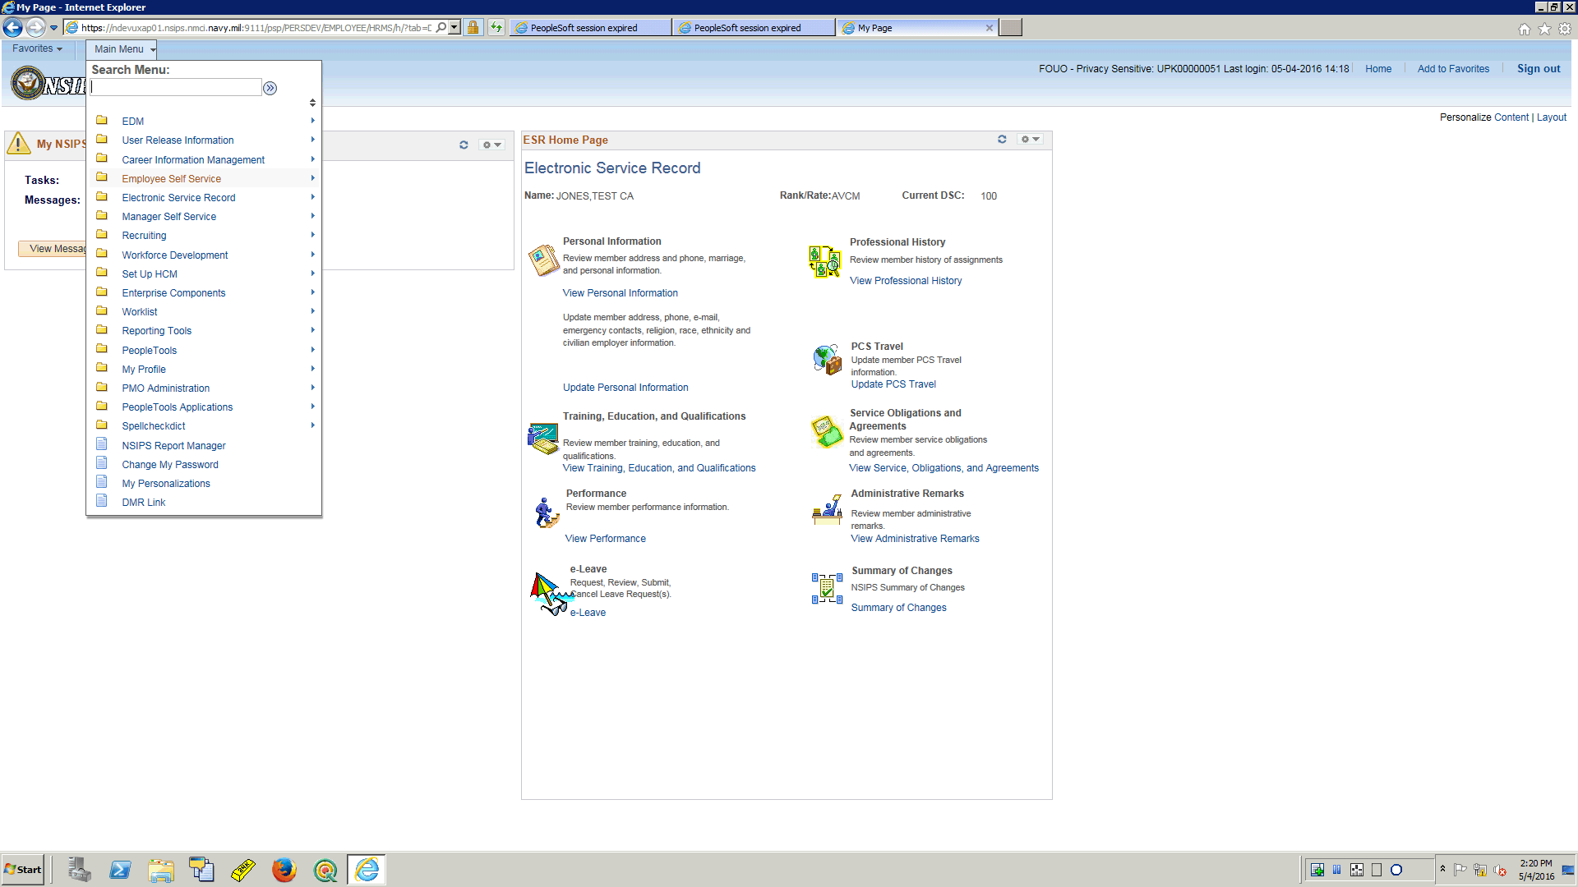

| **Step** | **Action** |
| --- | --- |
|  | Click the **Employee Self Service** menu. |

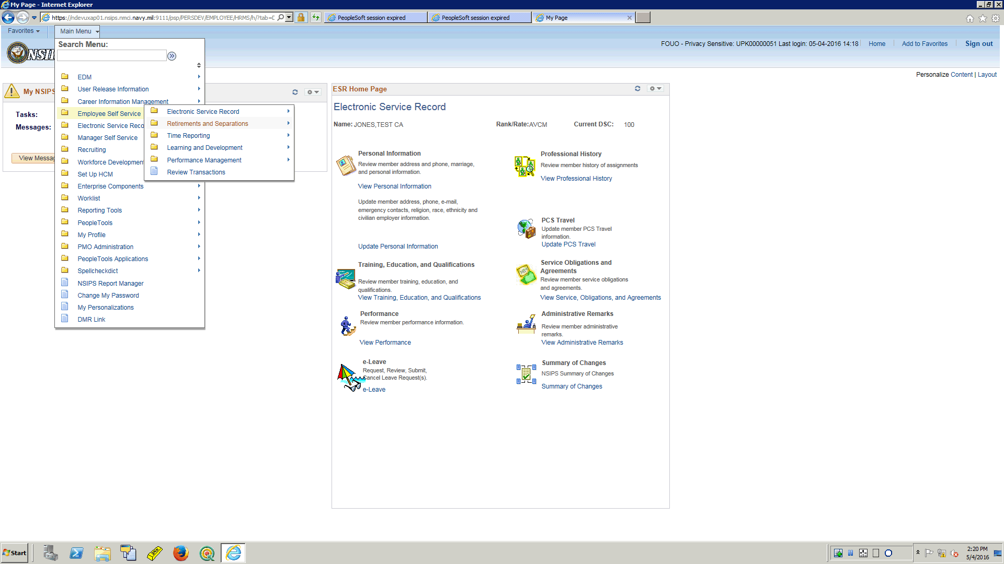

| **Step** | **Action** |
| --- | --- |
|  | Click the **Retirements and Separations** menu. |

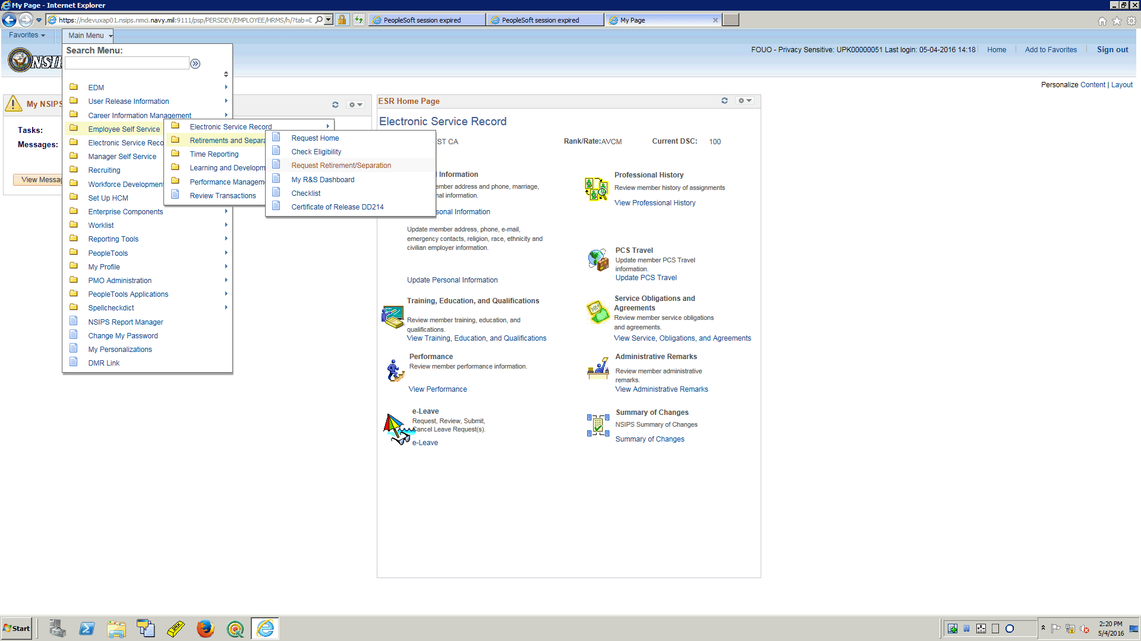

| **Step** | **Action** |
| --- | --- |
|  | Click the **Request Retirement/Separation** menu. |

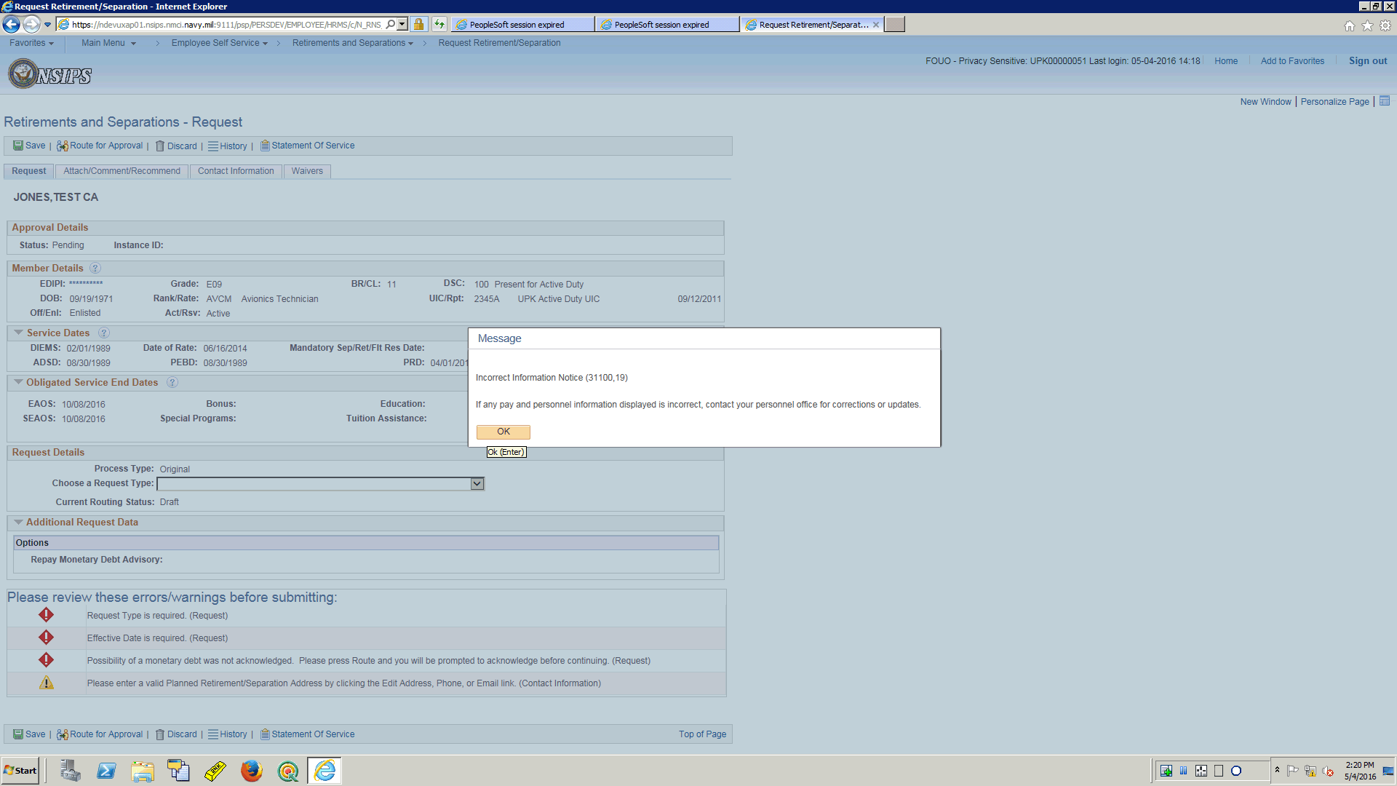

| **Step** | **Action** |
| --- | --- |
|  | Upon entry into the page the Service Member will receive a message notifying them who to contact if any pay and personnel information is not correct on the page.  Click OK to acknowledge.  Click the button. |

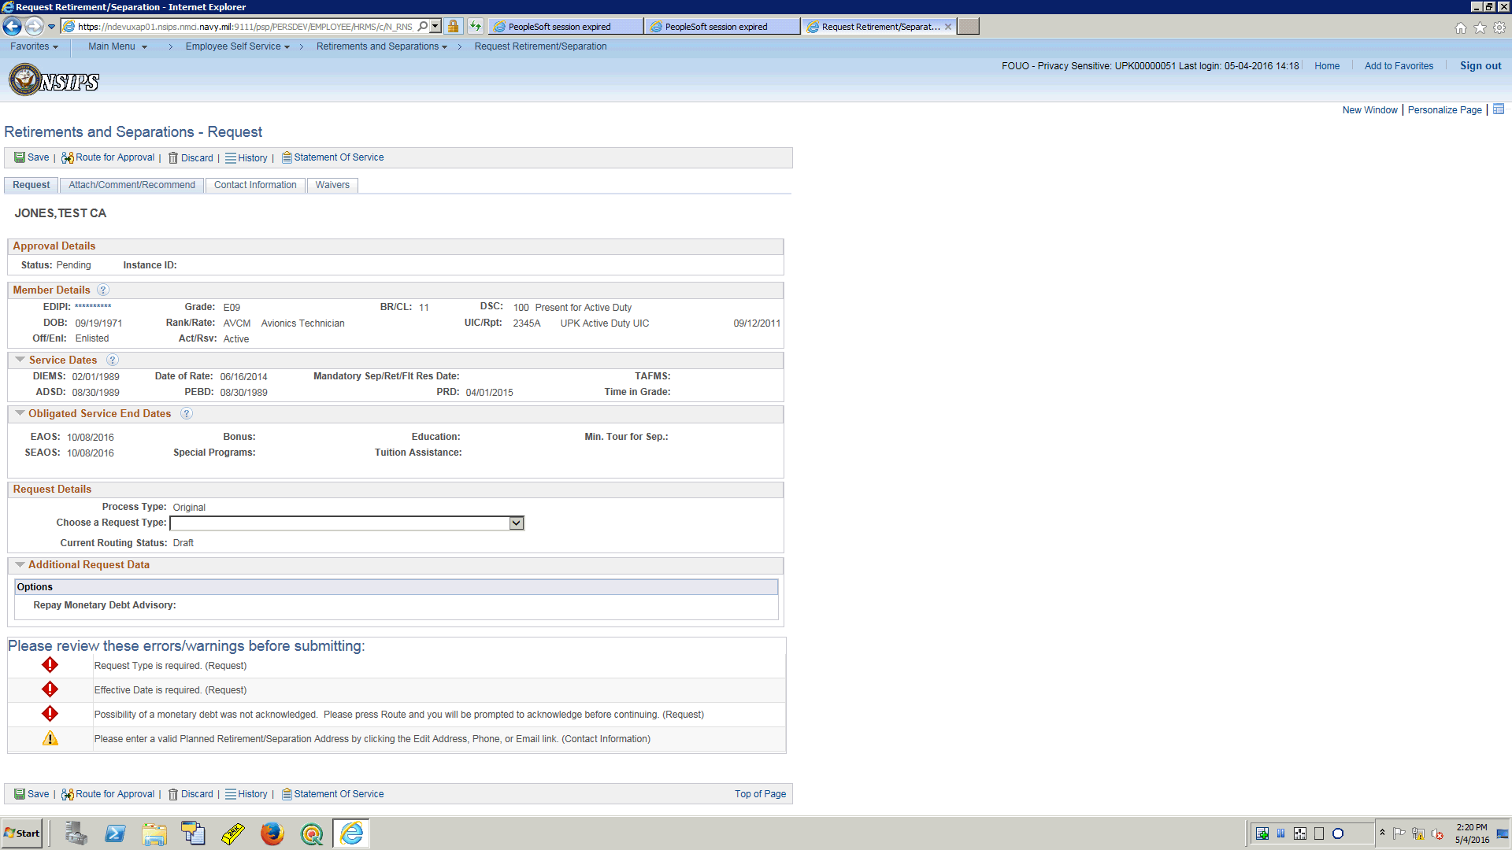

| **Step** | **Action** |
| --- | --- |
|  | The page opens up to the first tab which is the Request Tab.  This tab displays detailed data related to the member.  Next look at the Attach/Comment/Recommend Tab  Click the **Attach/Comment/Recommend** link. |

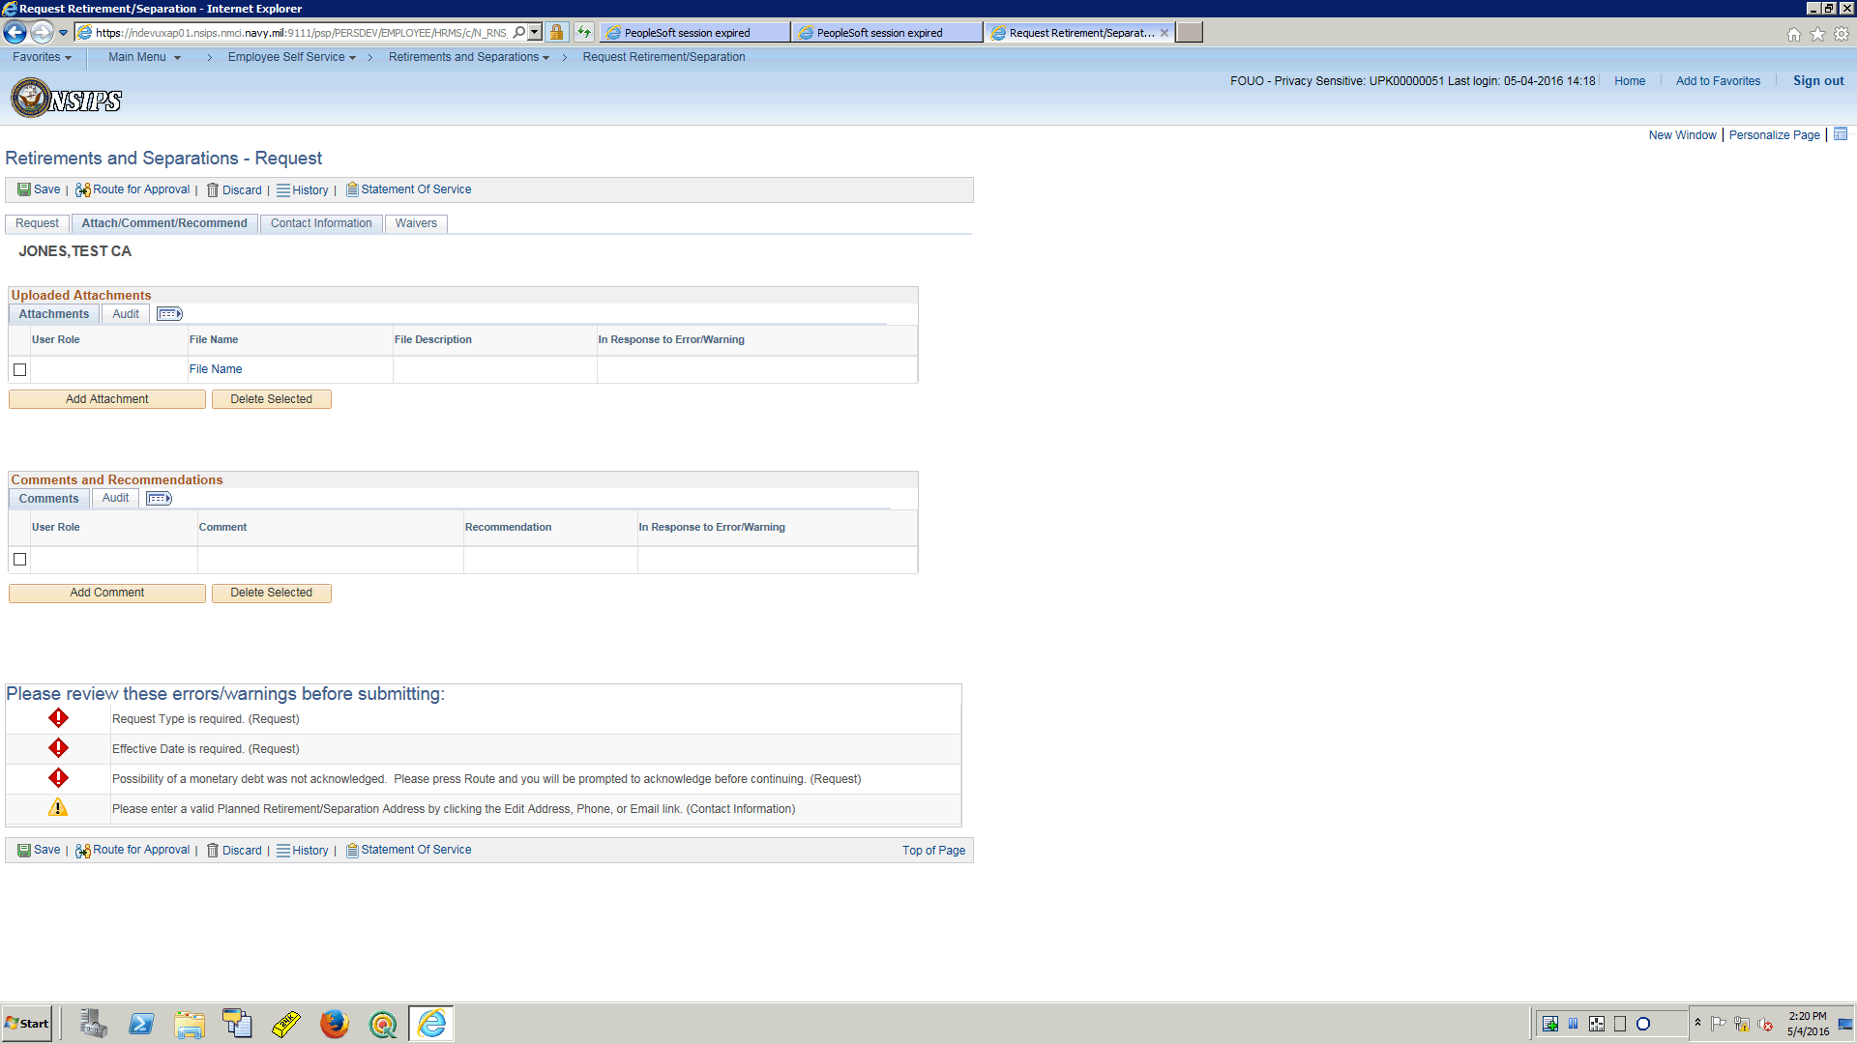

| **Step** | **Action** |
| --- | --- |
|  | There are multiple tabs present within the request.  This is the tab to Attach Documents, add comments and provide recommendations throughout the request submission life cycle.  Next look at the Contact Information Tab  Click the **Contact Information** link. |

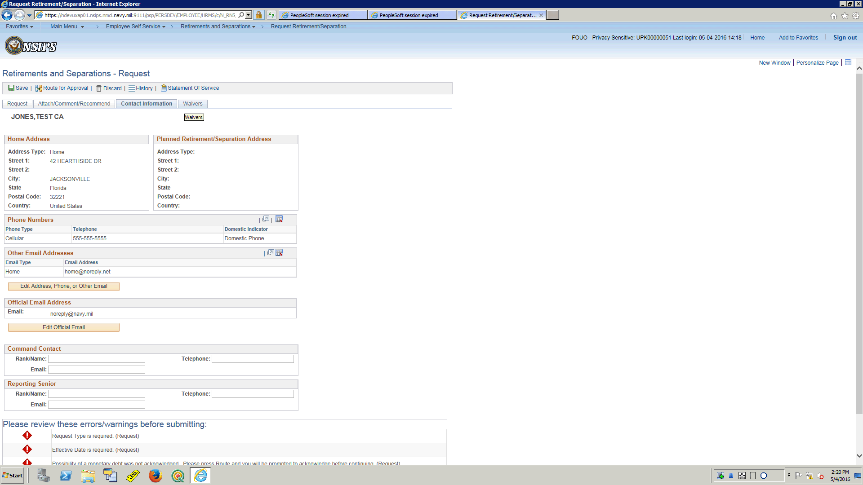

| **Step** | **Action** |
| --- | --- |
|  | This tab displays both displays and allows data input for contact information on both the Service Member and Command Points of Contact.  Next look at the Waivers Tab  Click the **Waivers** link. |

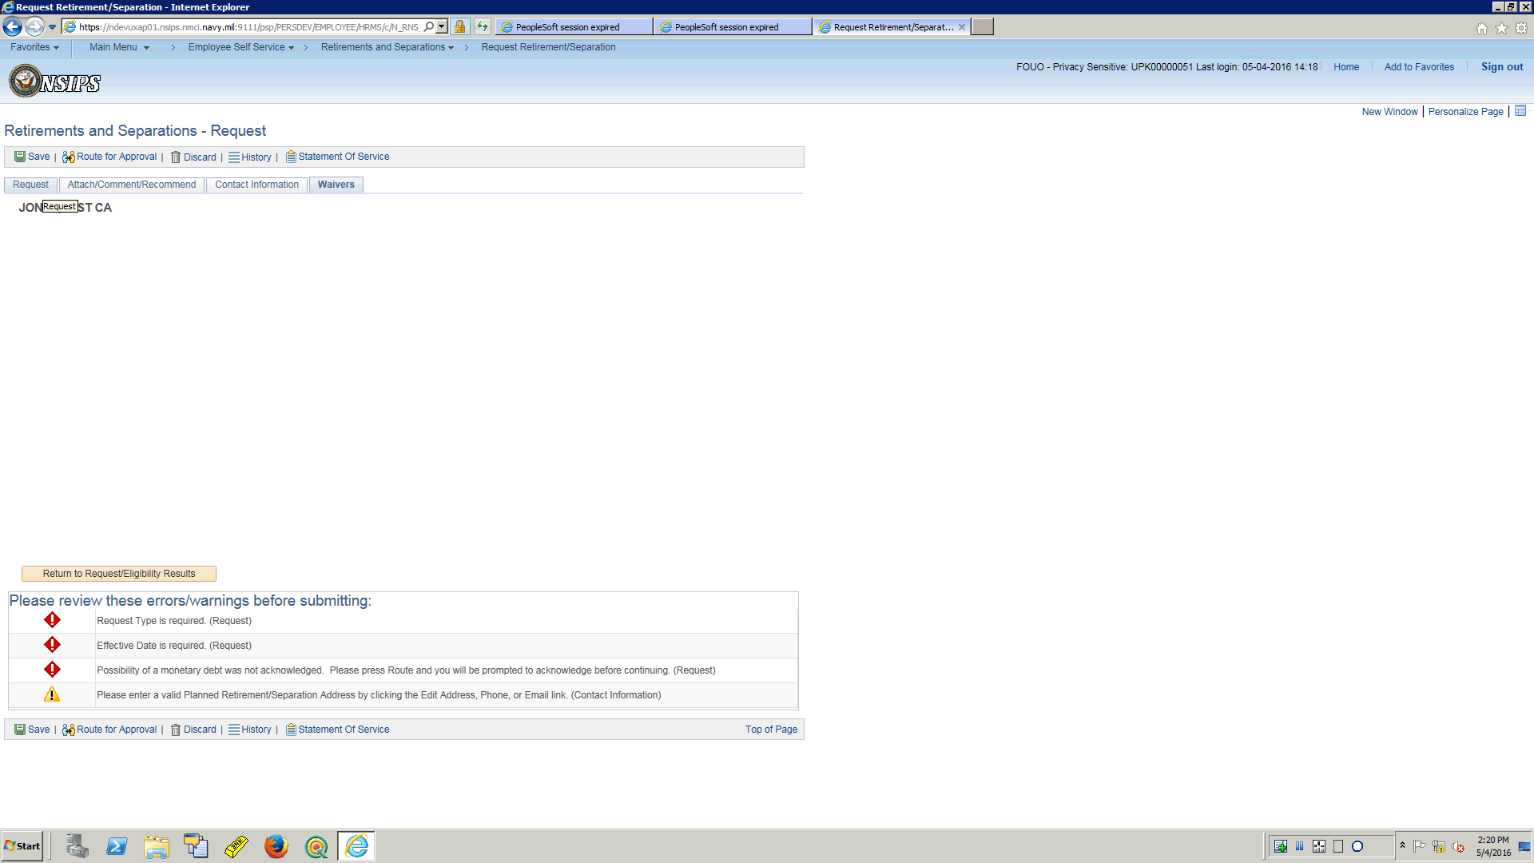

| **Step** | **Action** |
| --- | --- |
|  | This tab will store and display waivers associated with the request during the life cycle of the request.  It will allow for attachments, comments and recommendations to be made for each endorsement.  That is a high level look at the request, now click on the Request tab and let’s begin to submit a request.  Click the **Request** link. |

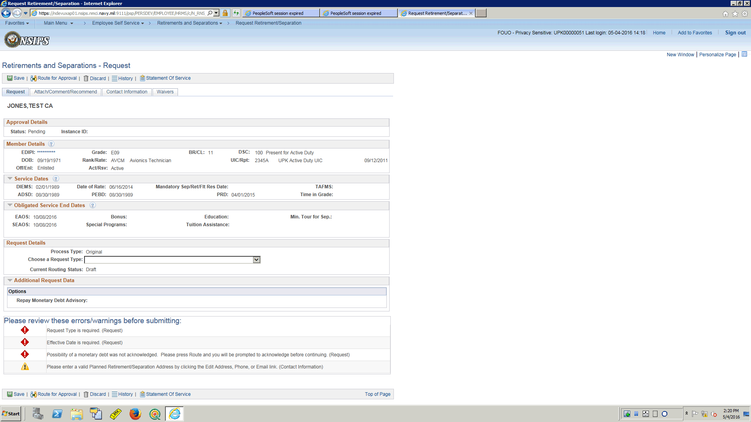

| **Step** | **Action** |
| --- | --- |
|  | The Service Member will use the drop down arrow to select which request they would like to submit.  Click the **Choose a Request Type** list. |

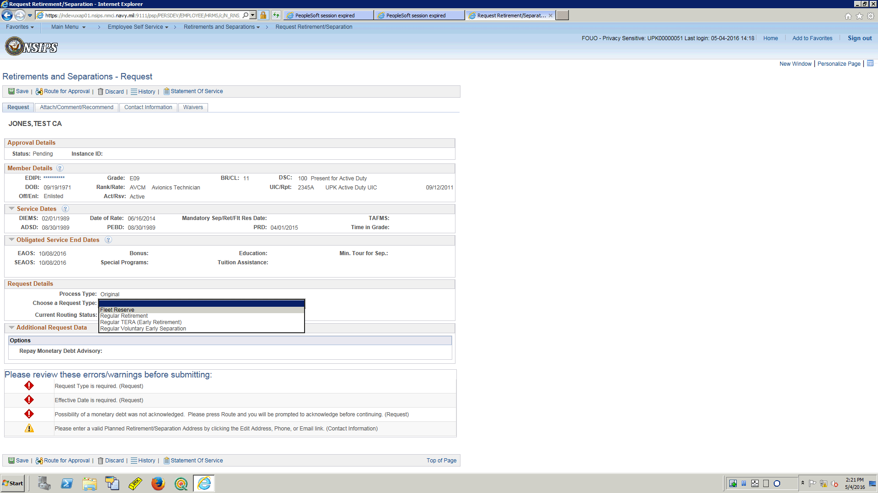

| **Step** | **Action** |
| --- | --- |
|  | For this training, this Service Member will request Transfer to the Fleet Reserve.  Note:  The request process is the same for all types; this is where the difference is.  Depending on the "TYPE" you select, there may be some addition data element requirements.  Notice though, because of this member being enlisted and on active duty, there are on four options for this member to choose from for their request.  For a Reserve member they would not see these options, they would have Non-Regular options that are not seen here.  The component has edits that will preclude any Service Member from being given an option to submit for a type of Separation or Retirement they could not qualify for.  Click the **Fleet Reserve** list item. |

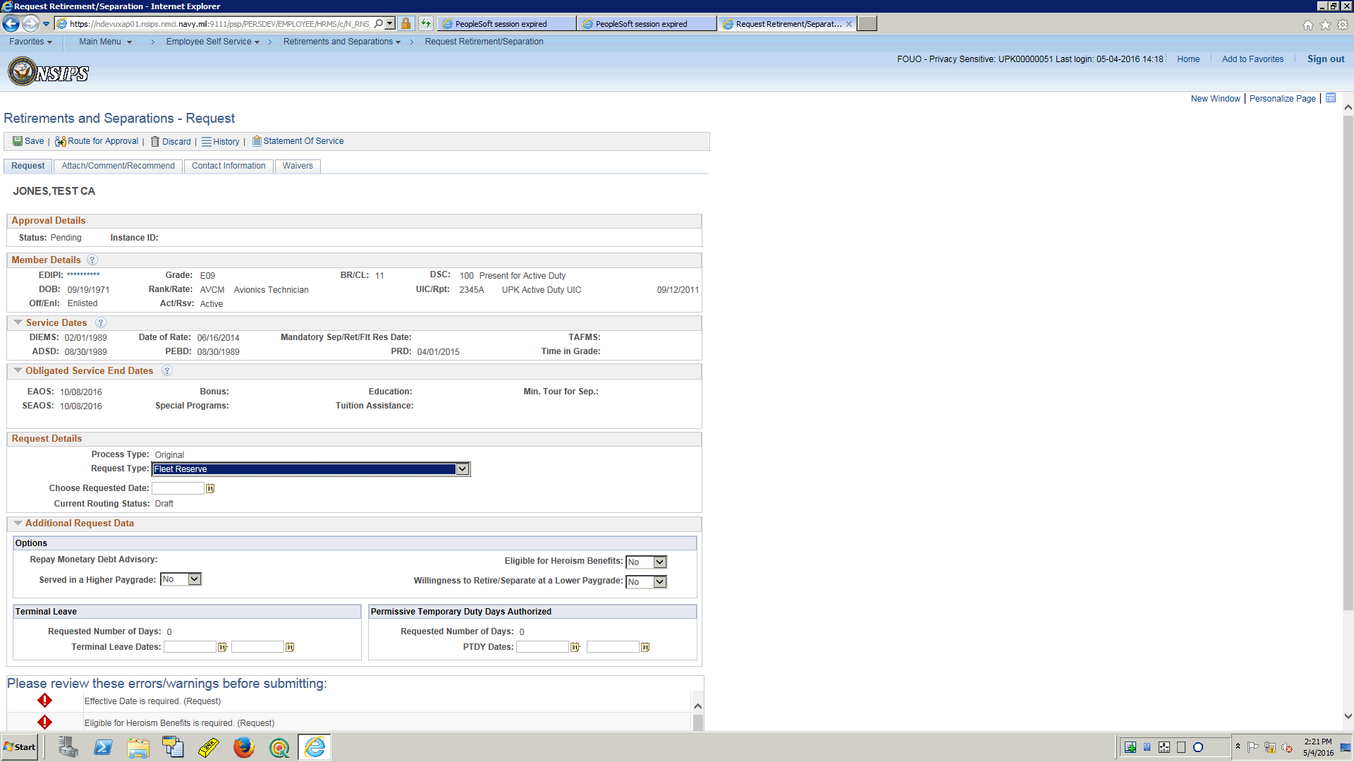

| **Step** | **Action** |
| --- | --- |
|  | Once a type has been selected, a Requested Date is required to be selected.  This can be done by using the NSIPS calendar button.  Click the **Choose a date (Alt+5)** button. |

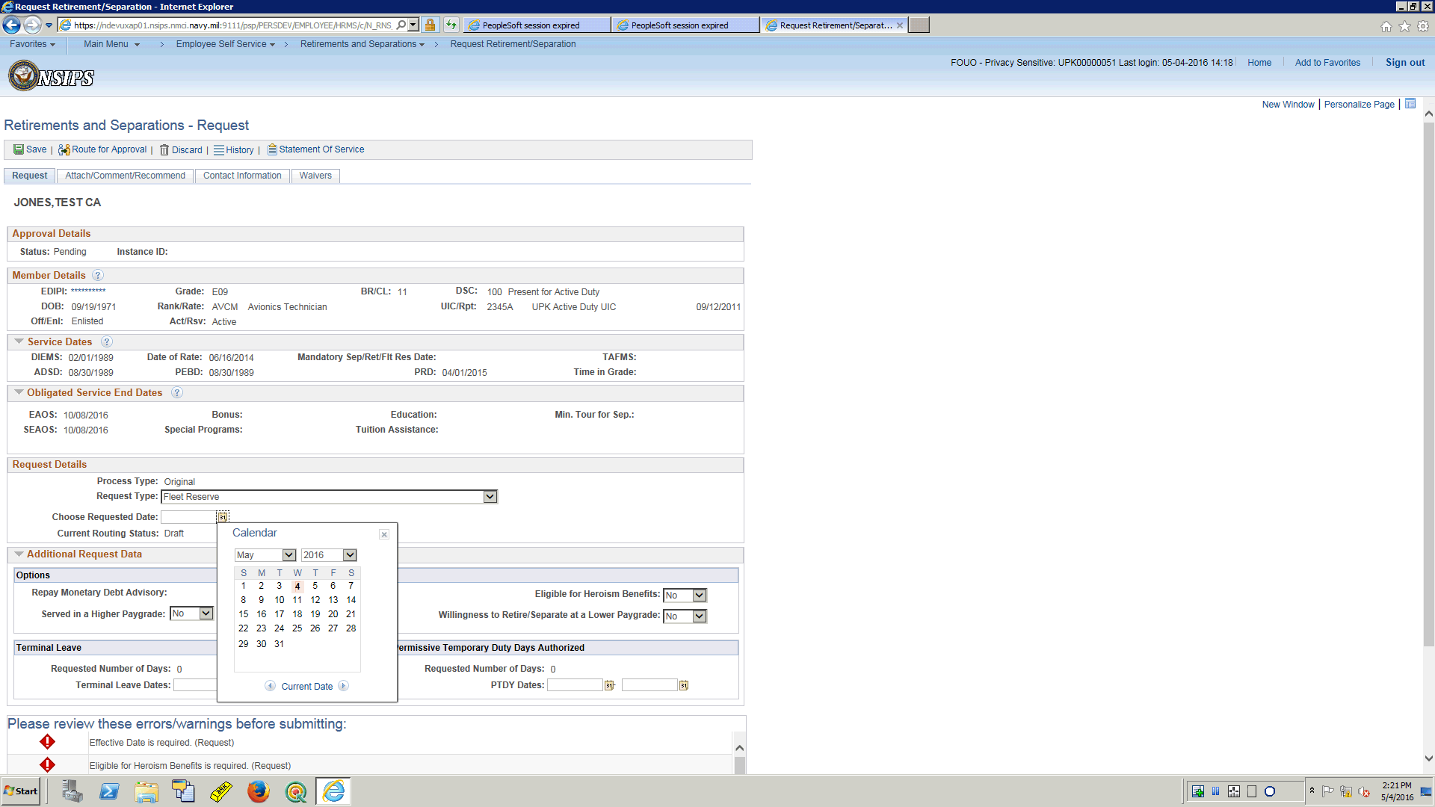

| **Step** | **Action** |
| --- | --- |
|  | Prior to selecting May 31, take note that presently there is an error message to left of the page stating that an effective date is required.  Once the date is selected notice the message will disappear.  Click the **31** object. |

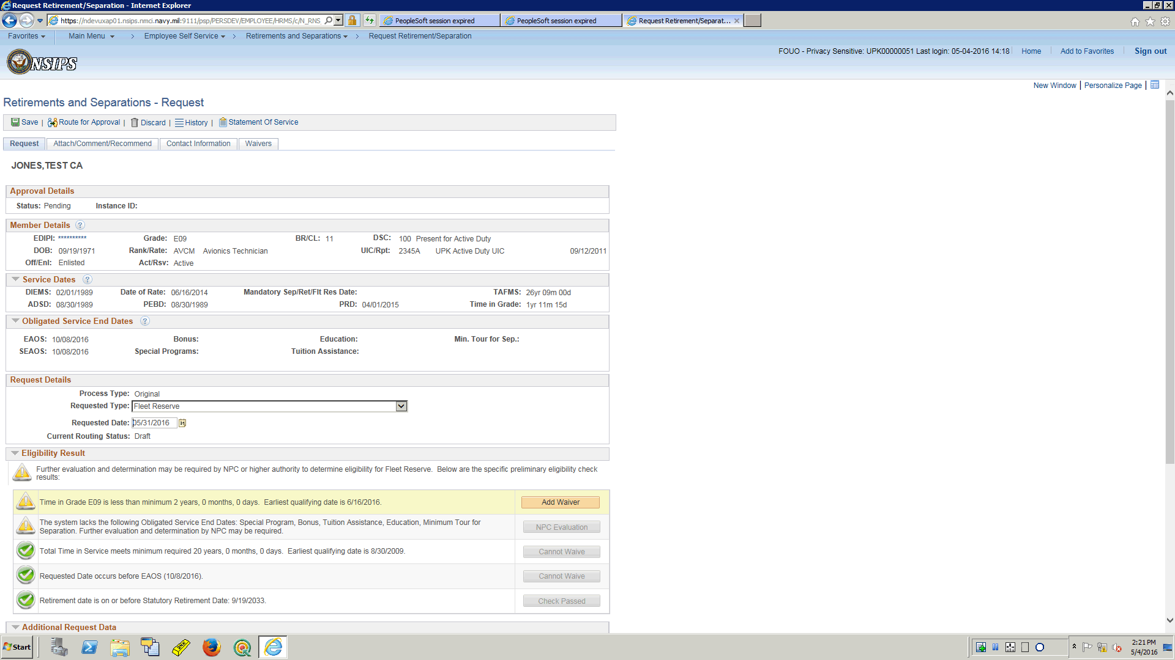

| **Step** | **Action** |
| --- | --- |
|  | Note the error messages are gone and we have Eligibility results to review.  There are two warnings and three checks that are good to go.  Reviewing the warnings, the first is the Service member is lacking the Time in Grade required to retire at current paygrade.  This can be approved with a waiver so click the Add Waiver button to start that process.  Click the **Add Waiver** button. |

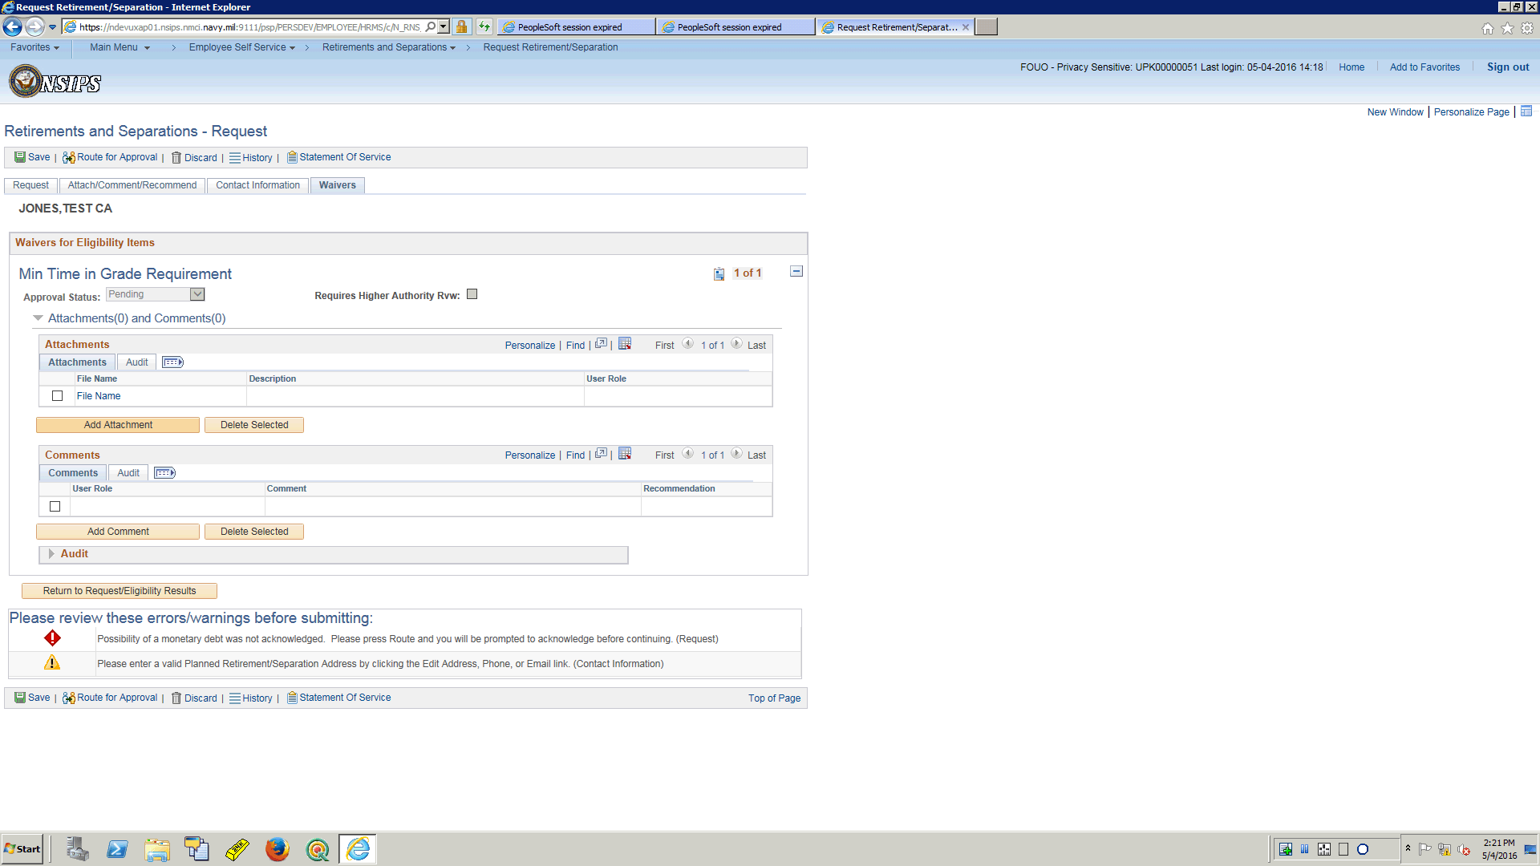

| **Step** | **Action** |
| --- | --- |
|  | Once the add waiver button is selected the user is taken directly to the wavers tab and the waiver for Minimum Time in Grade Waiver has been loaded to be processed.  In this training topic the Service Member has prepared a letter to submit explaining his hardship.  Click the **Add Attachment** button. |

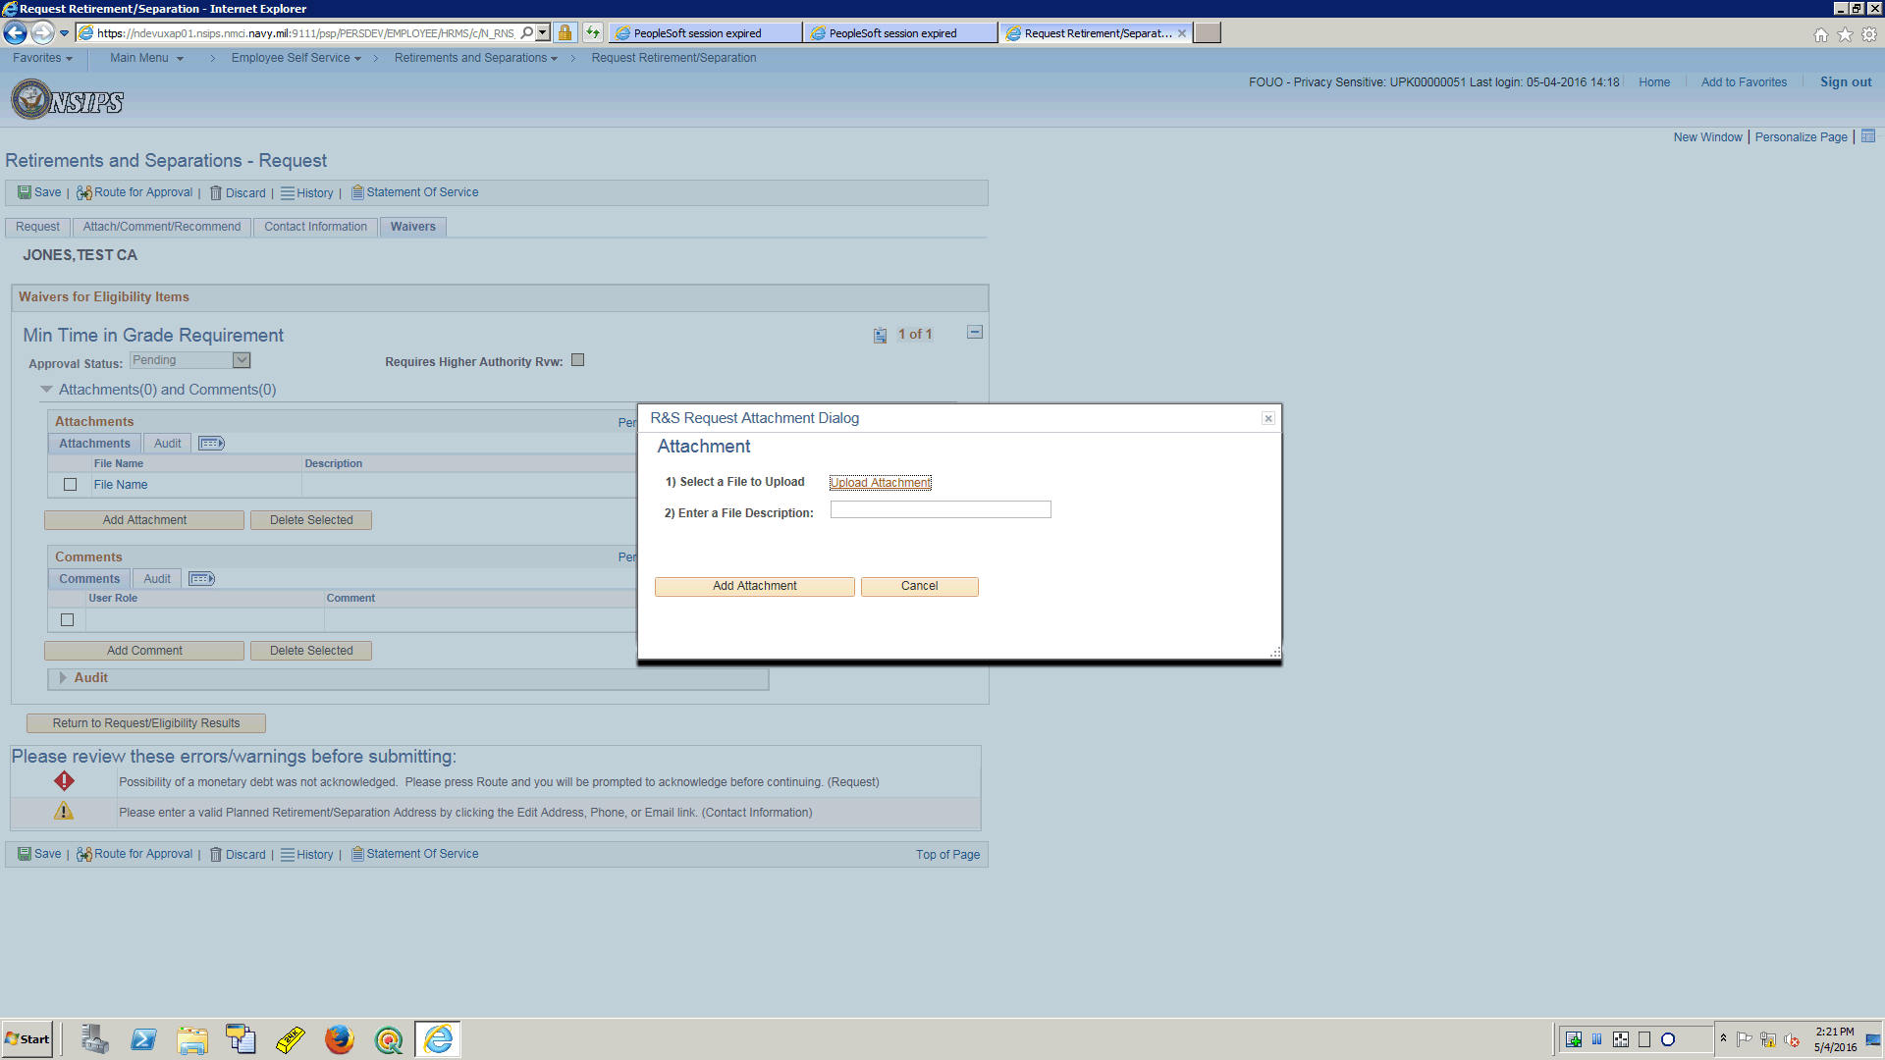

| **Step** | **Action** |
| --- | --- |
|  | Click on upload attachment  Click the **Upload Attachment** link. |

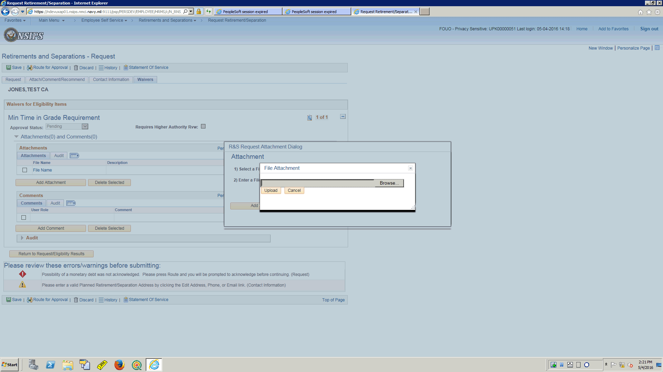

| **Step** | **Action** |
| --- | --- |
|  | You will browse to locate where you have stored your letter to have it uploaded from your computer or other device.  Click in the **Upload** field. |

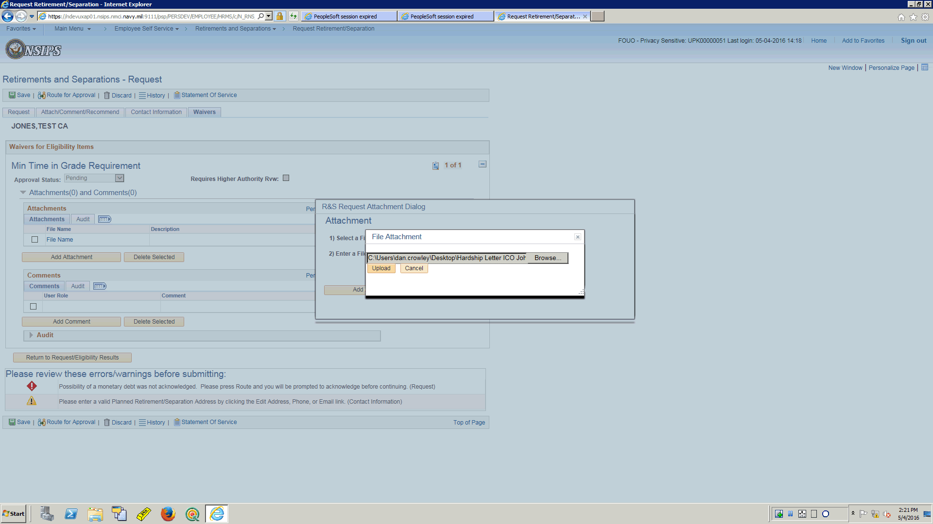

| **Step** | **Action** |
| --- | --- |
|  | Once you have located and selected the file it will appear in the window ready to upload.  Once you have the document you want to attach, click the Upload button.  Click the **Upload** button. |

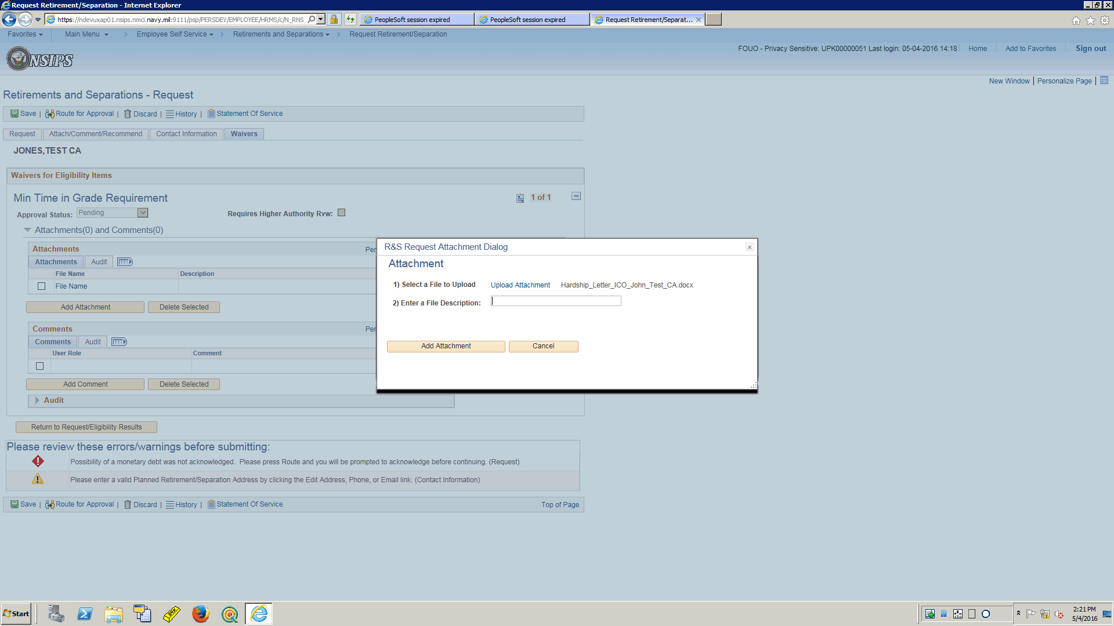

| **Step** | **Action** |
| --- | --- |
|  | Enter a short description of the uploaded file here.  Enter the desired information into the **2) Enter a File Description** field. Enter "**Hardship Letter**". |

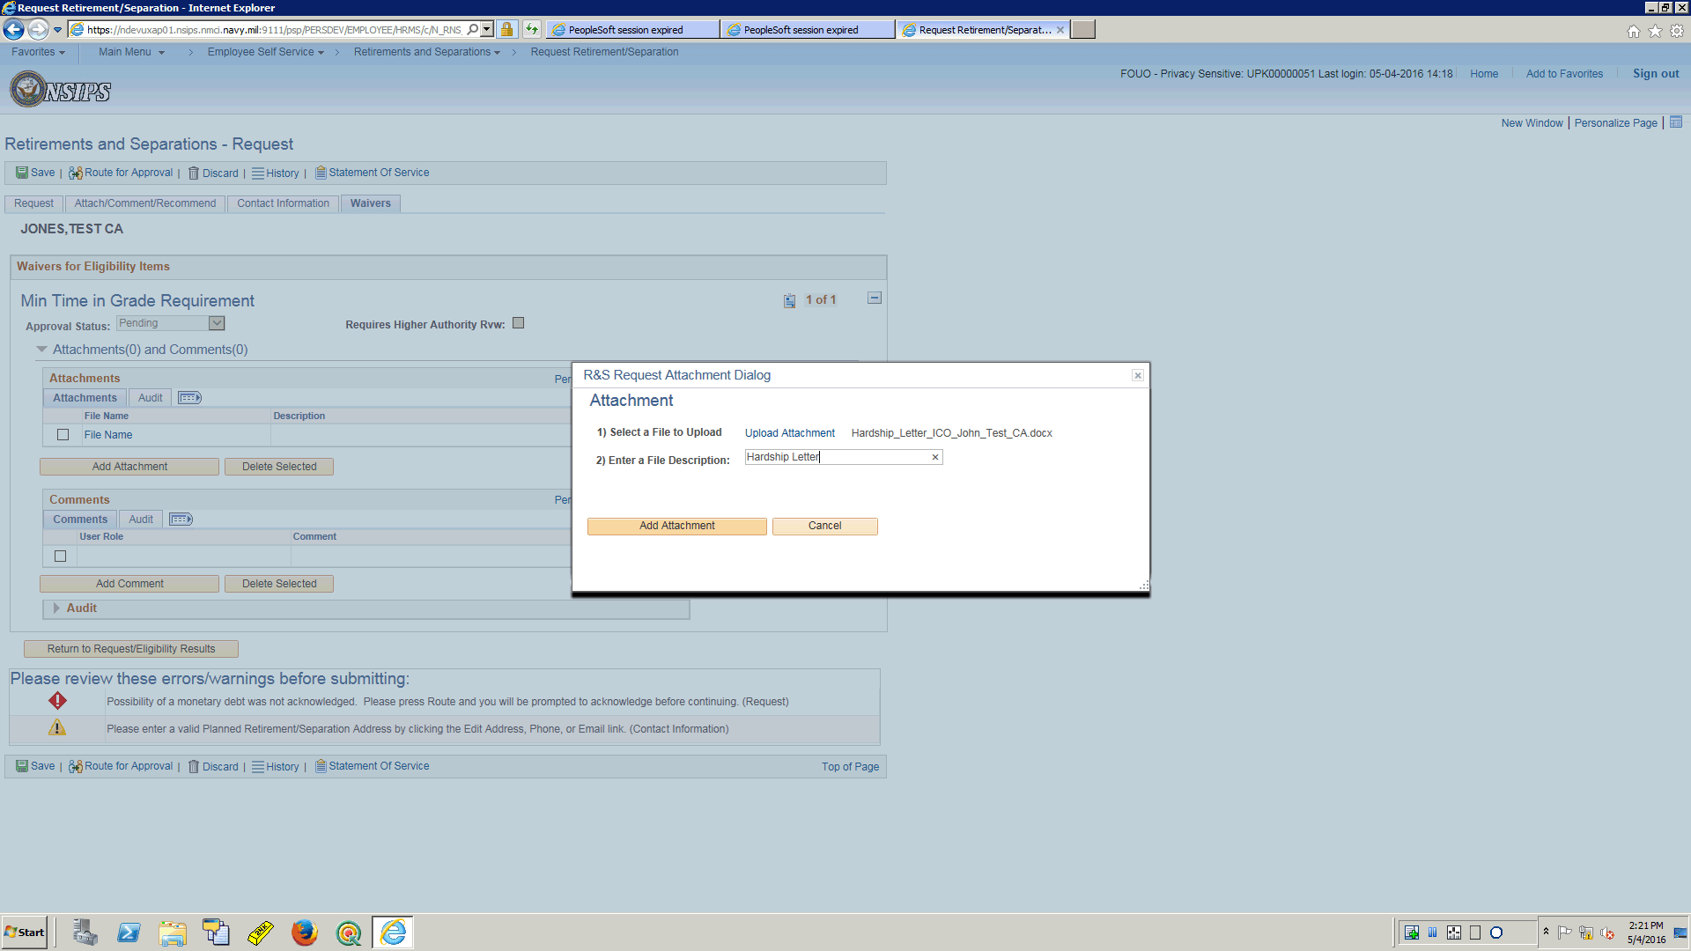

| **Step** | **Action** |
| --- | --- |
|  | Once entered select Add Attachment.  Click the **Add Attachment** button. |

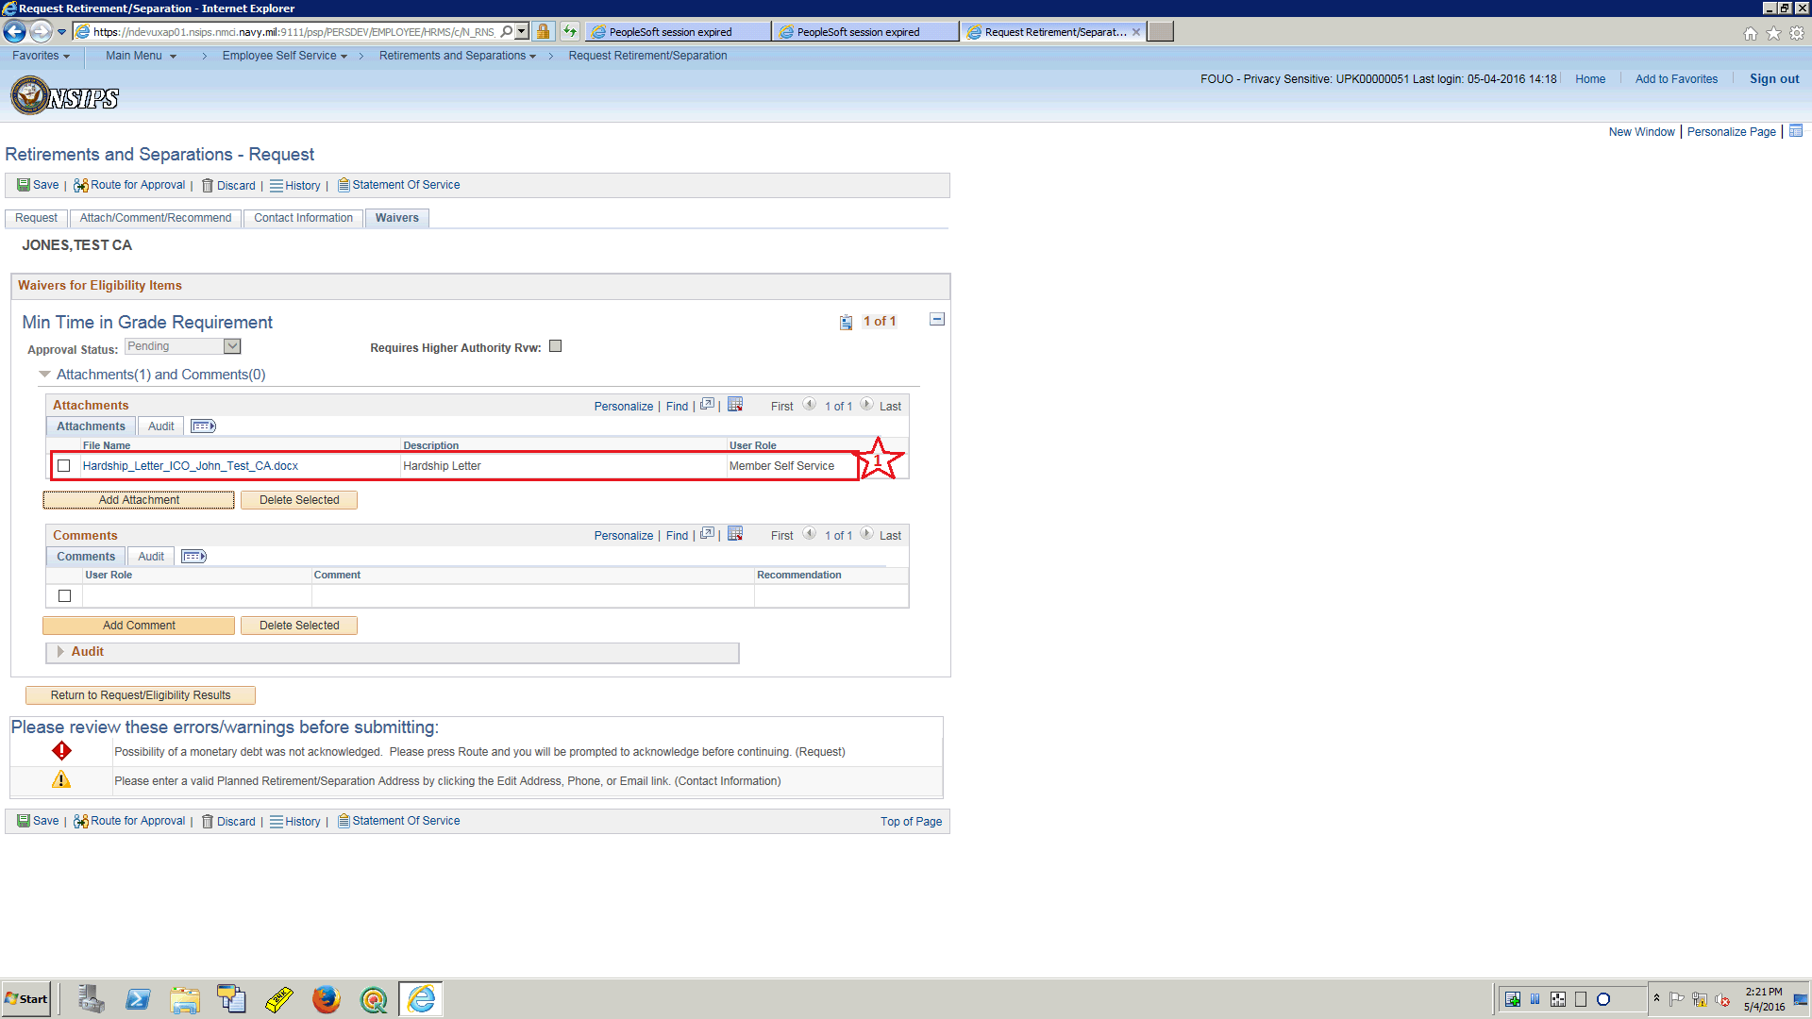

| **Step** | **Action** |
| --- | --- |
|  | 1.  Notice the Letter is now attached to the request.  Next the Service member has the option to add comments  Click the **Add Comment** button. |

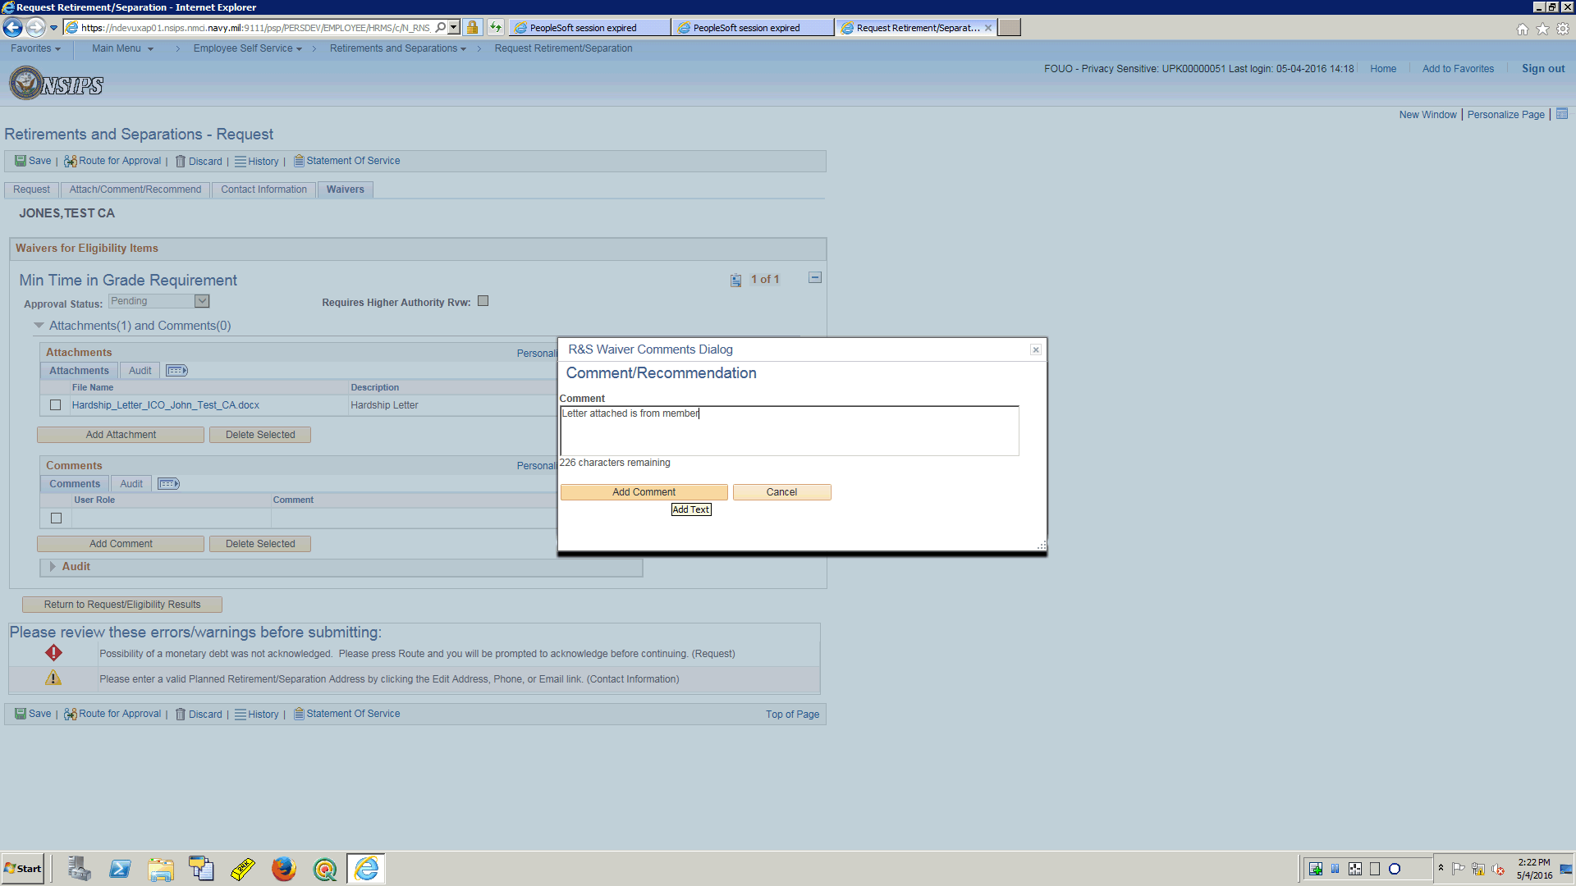

| **Step** | **Action** |
| --- | --- |
|  | Member will type desired comments here.  Once completed, click the Add Comment Button.  Click the **Add Comment** button. |

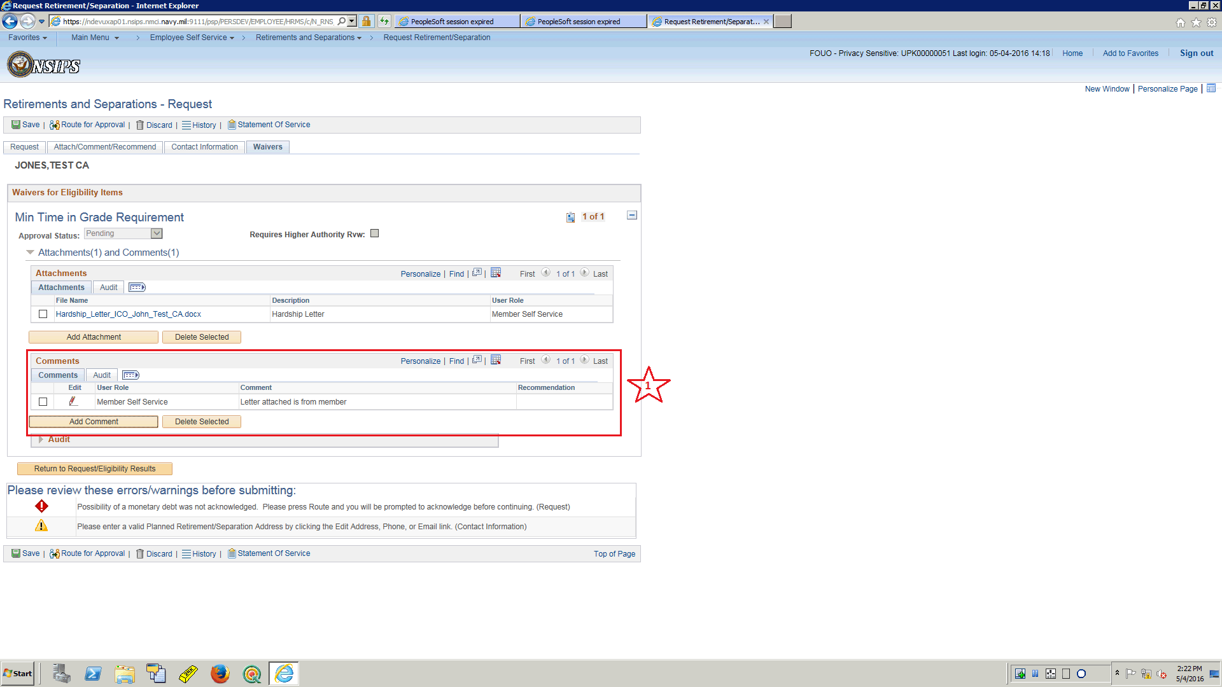

| **Step** | **Action** |
| --- | --- |
|  | 1.  Notice that the comments are reflected as added to the request.  The Service Member Has requested the waiver, attached a Letter as a document and added comments for consideration.  Click on the Return to Request Button to continue with request.  Click the **Return to Request/Eligibility Results** button. |

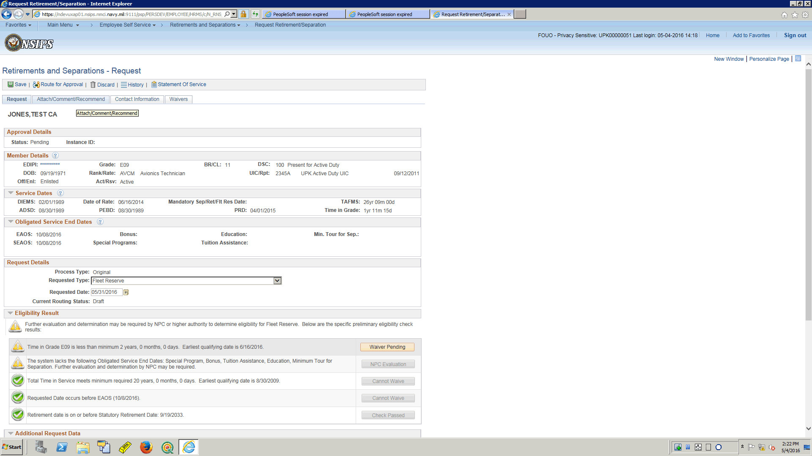

| **Step** | **Action** |
| --- | --- |
|  | The application has returned the Service Member back to the place where they left off prior to adding the waiver.  Next Warning is related to system dates possibly needing some review by higher authority since they are not present on this page.  This will not preclude the member from submitting the request.  These dates will be validated if needed during the request lifecycle.  Click the next tab to continue.  Click the **Attach/Comment/Recommend** link. |

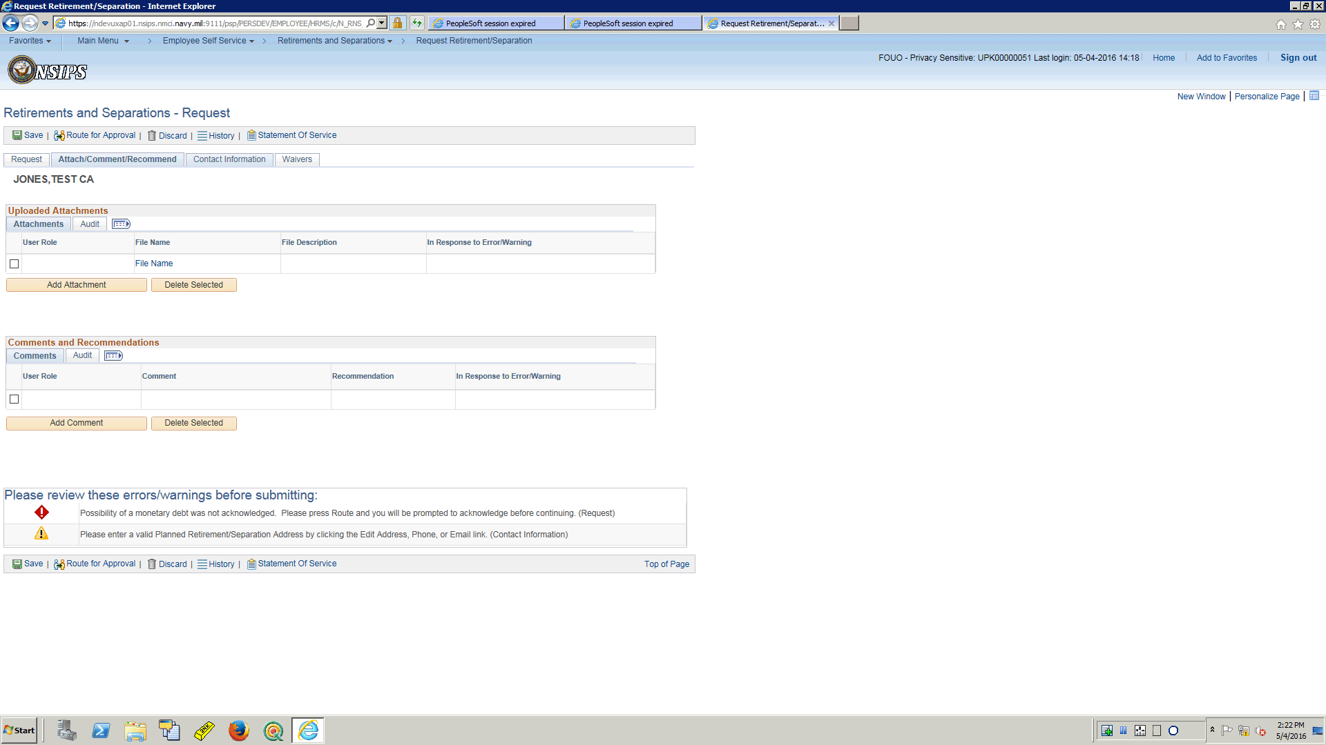

| **Step** | **Action** |
| --- | --- |
|  | This tab is used to attach any supporting documentation for the request.  It is also used to Comment on the request and makes recommendations regarding the request.  For this training topic the member has a waiver where he attached his letter and made his comments concerning his request.  If he did not have the waiver and needed to include those items with the request, this is where it would be completed.  In this training topic, no further entries required on this tab for the Service Member.  Click the **Contact Information** link. |

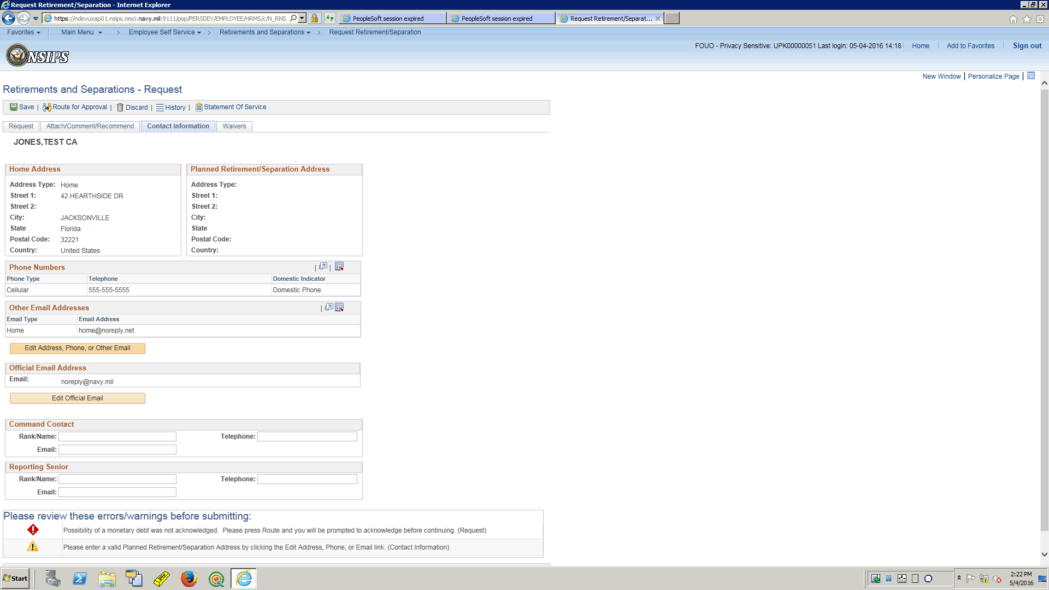

| **Step** | **Action** |
| --- | --- |
|  | The Contact Information tab will need to be updated by the Service Member to provide the Planned Retirement/Separation Address.  There is similar functionality here to add a row, delete a row, input text, look up icon, and drop down arrows to complete the data input.  First the Service Member will update the planned Retirement/Separation Address.  Click the **Edit Address, Phone, or Other Email** button. |

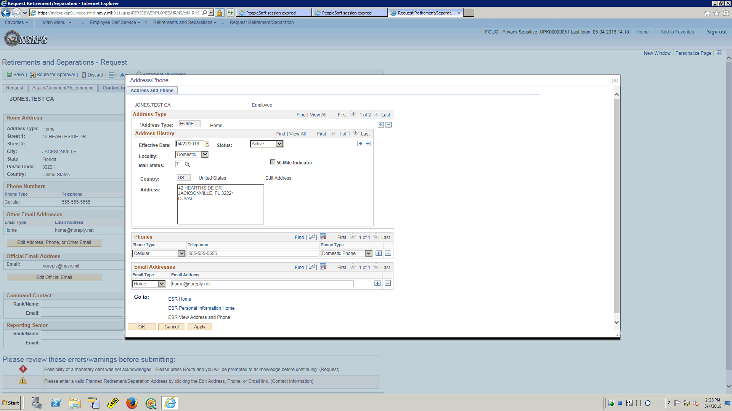

| **Step** | **Action** |
| --- | --- |
|  | Click the plus (+) button to add an address.  Click the **Add a new row at row 1 (Alt+7)** link. |

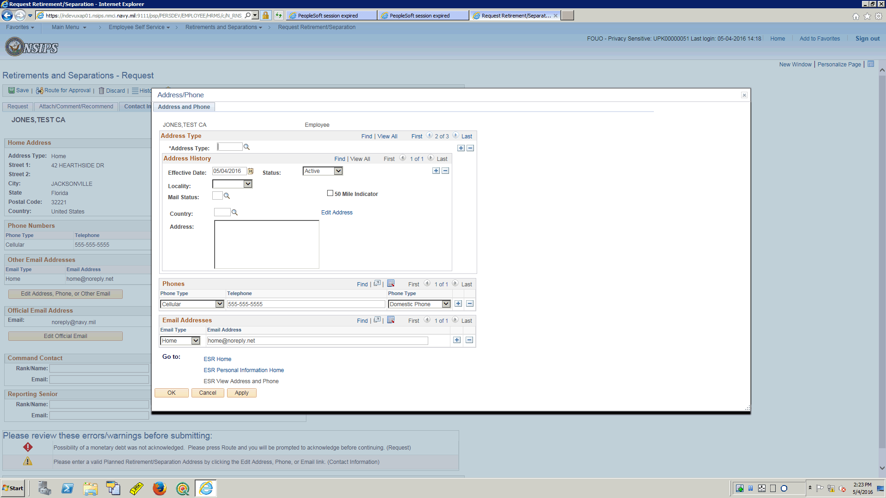

| **Step** | **Action** |
| --- | --- |
|  | Select an address type using the look up icon  Click the **Look up Address Type (Alt+5)** button. |

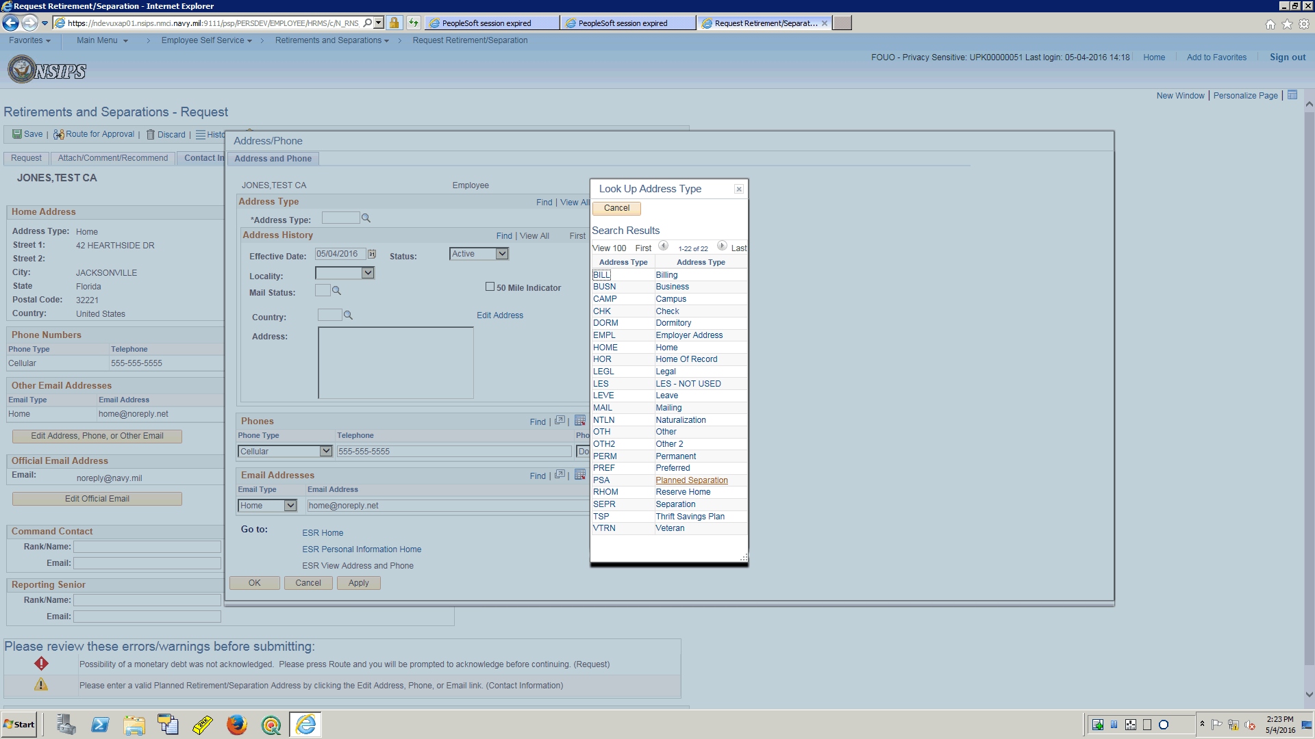

| **Step** | **Action** |
| --- | --- |
|  | For this training topic select "PSA"  Click the **Planned Separation** link. |

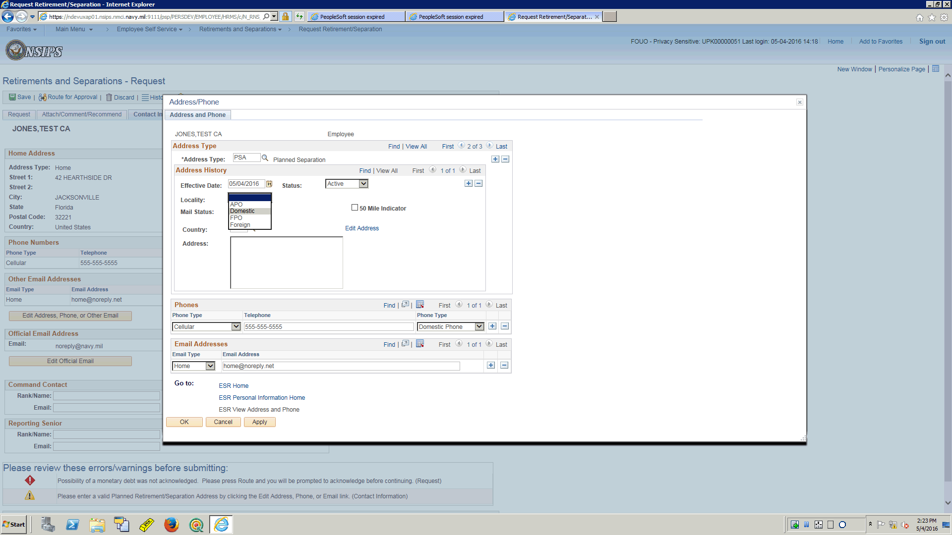

| **Step** | **Action** |
| --- | --- |
|  | Use the Locality drop down arrow to select Domestic.  Click the **Domestic** list item. |

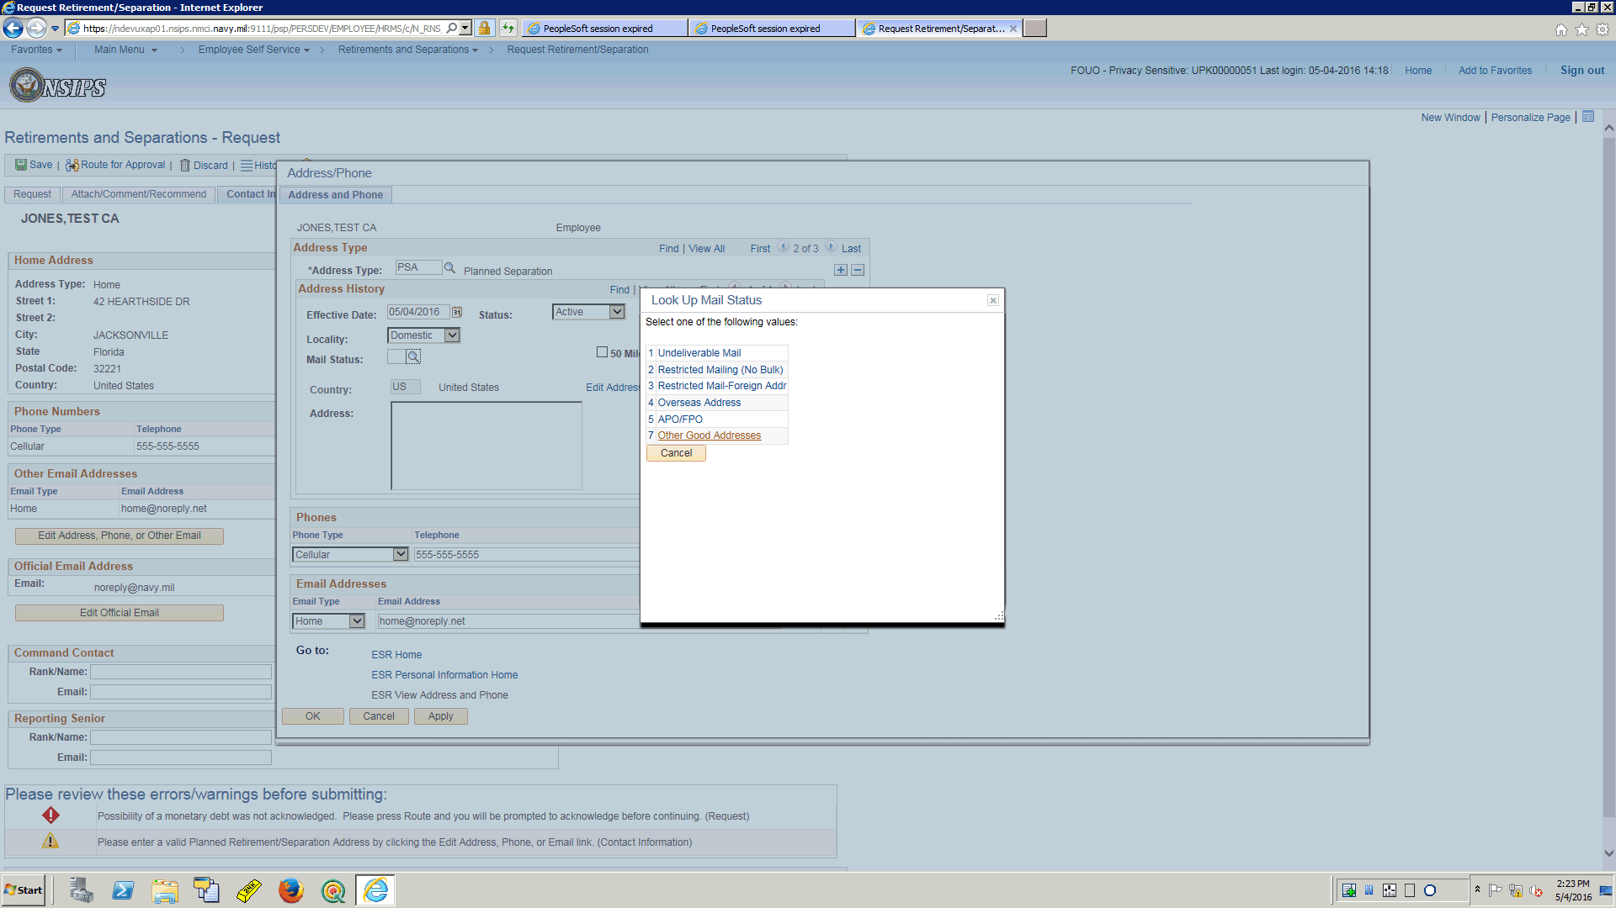

| **Step** | **Action** |
| --- | --- |
|  | Use the Mail Status look up icon to select "7"  Click the **Other Good Addresses** link. |

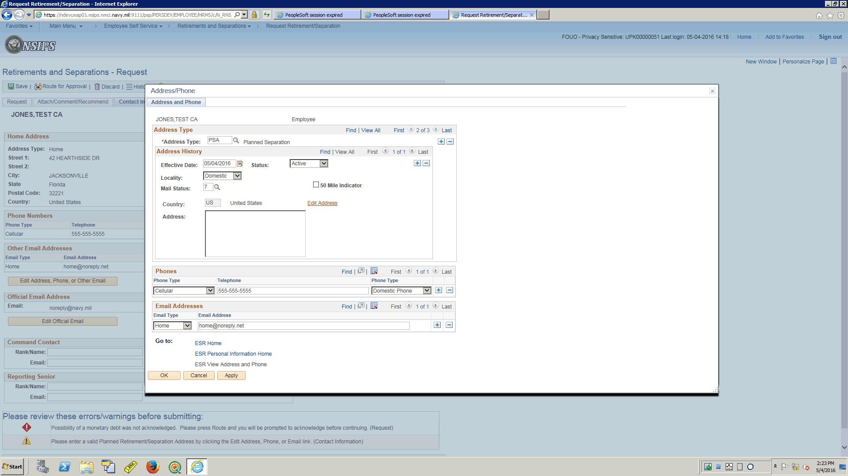

| **Step** | **Action** |
| --- | --- |
|  | Enter physical address  Click the **Edit Address** link. |

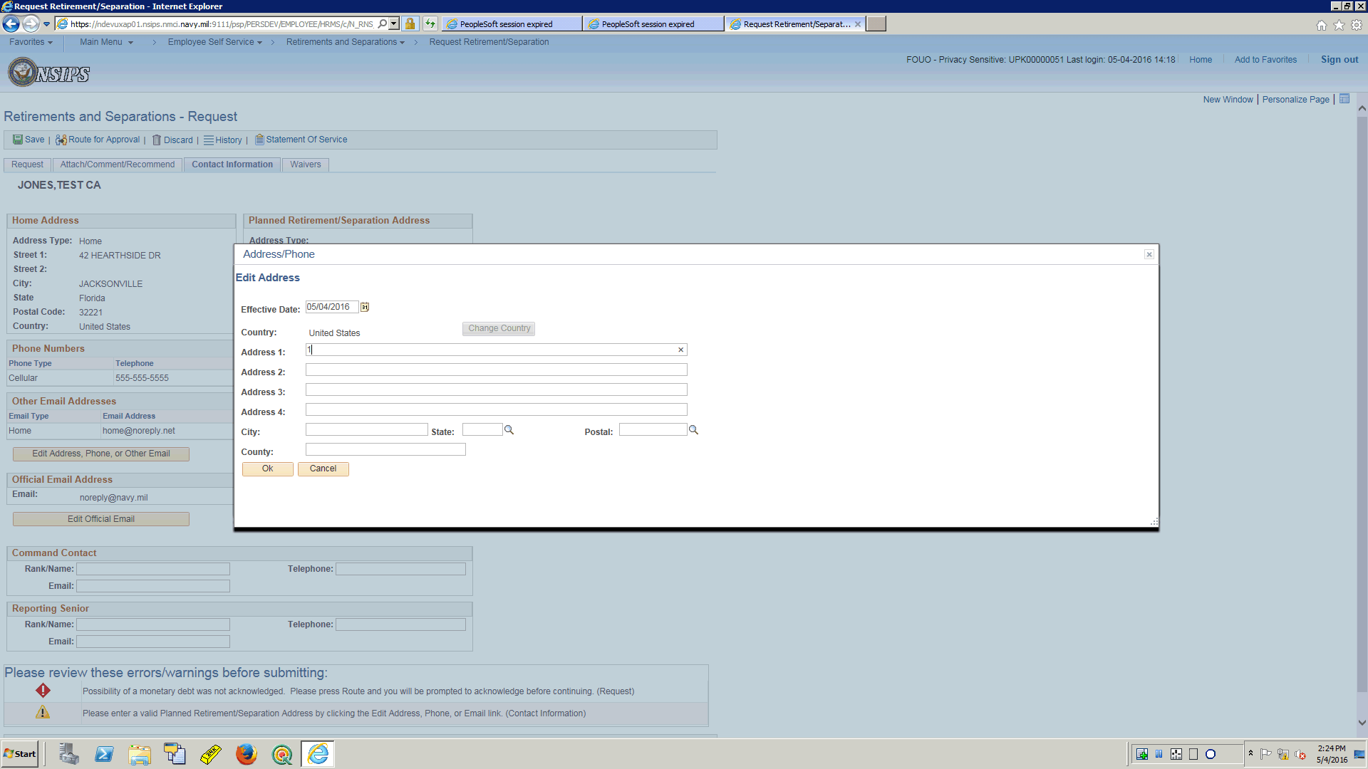

| **Step** | **Action** |
| --- | --- |
|  | Enter Street  Enter the desired information into the **Address 1** field. Enter "**115 Cabot St**". |

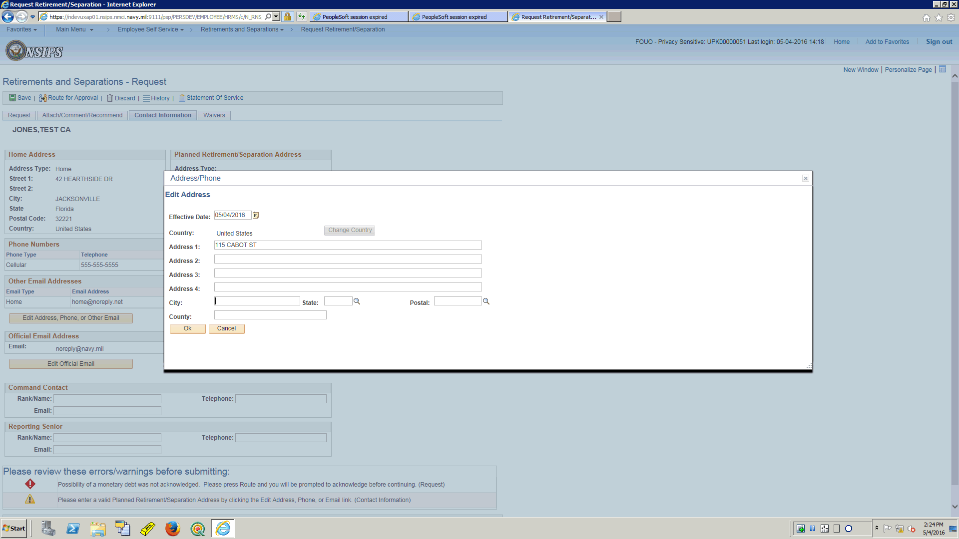

| **Step** | **Action** |
| --- | --- |
|  | Enter City  Enter the desired information into the **City** field. Enter "**Beverly**". |

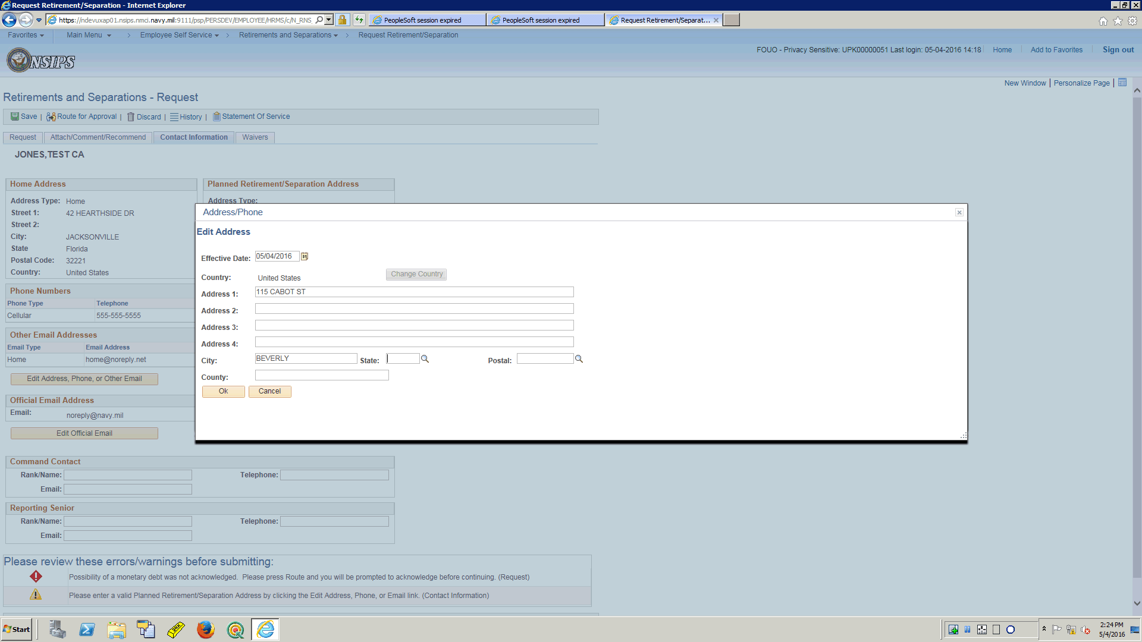

| **Step** | **Action** |
| --- | --- |
|  | Enter State  Enter the desired information into the **State** field. Enter "**MA**". |

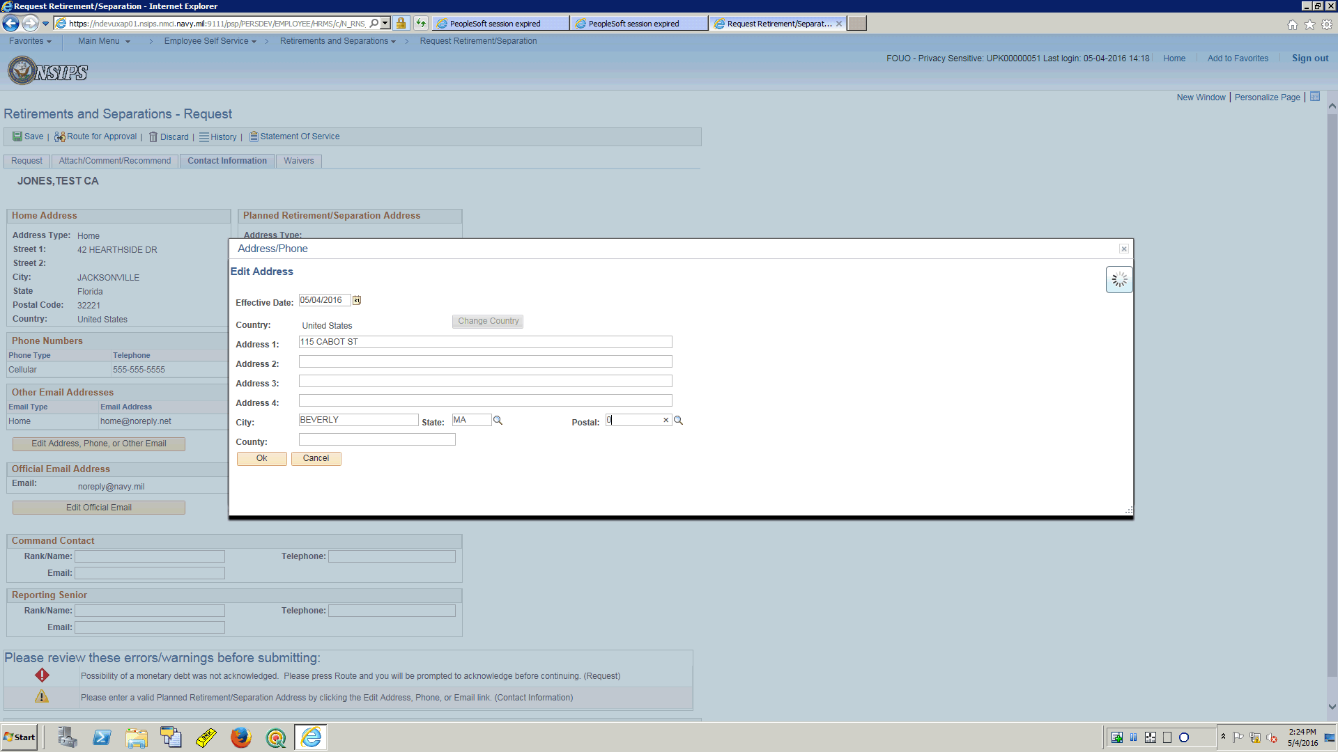

| **Step** | **Action** |
| --- | --- |
|  | Enter Zip Code  Enter the desired information into the **Postal** field. Enter "**01915**". |

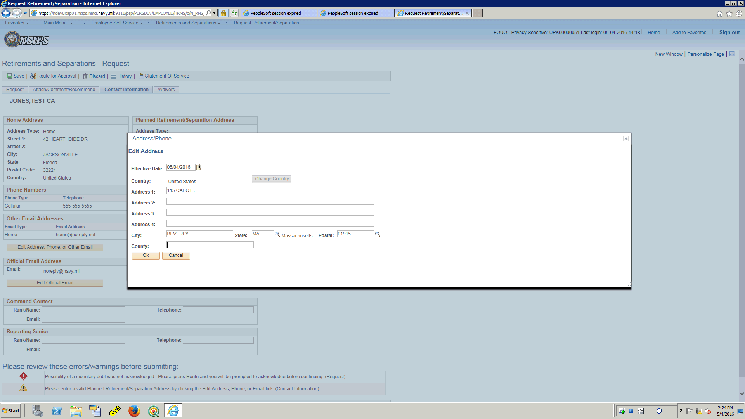

| **Step** | **Action** |
| --- | --- |
|  | Enter the County  Enter the desired information into the **County** field. Enter "**Essex**". |

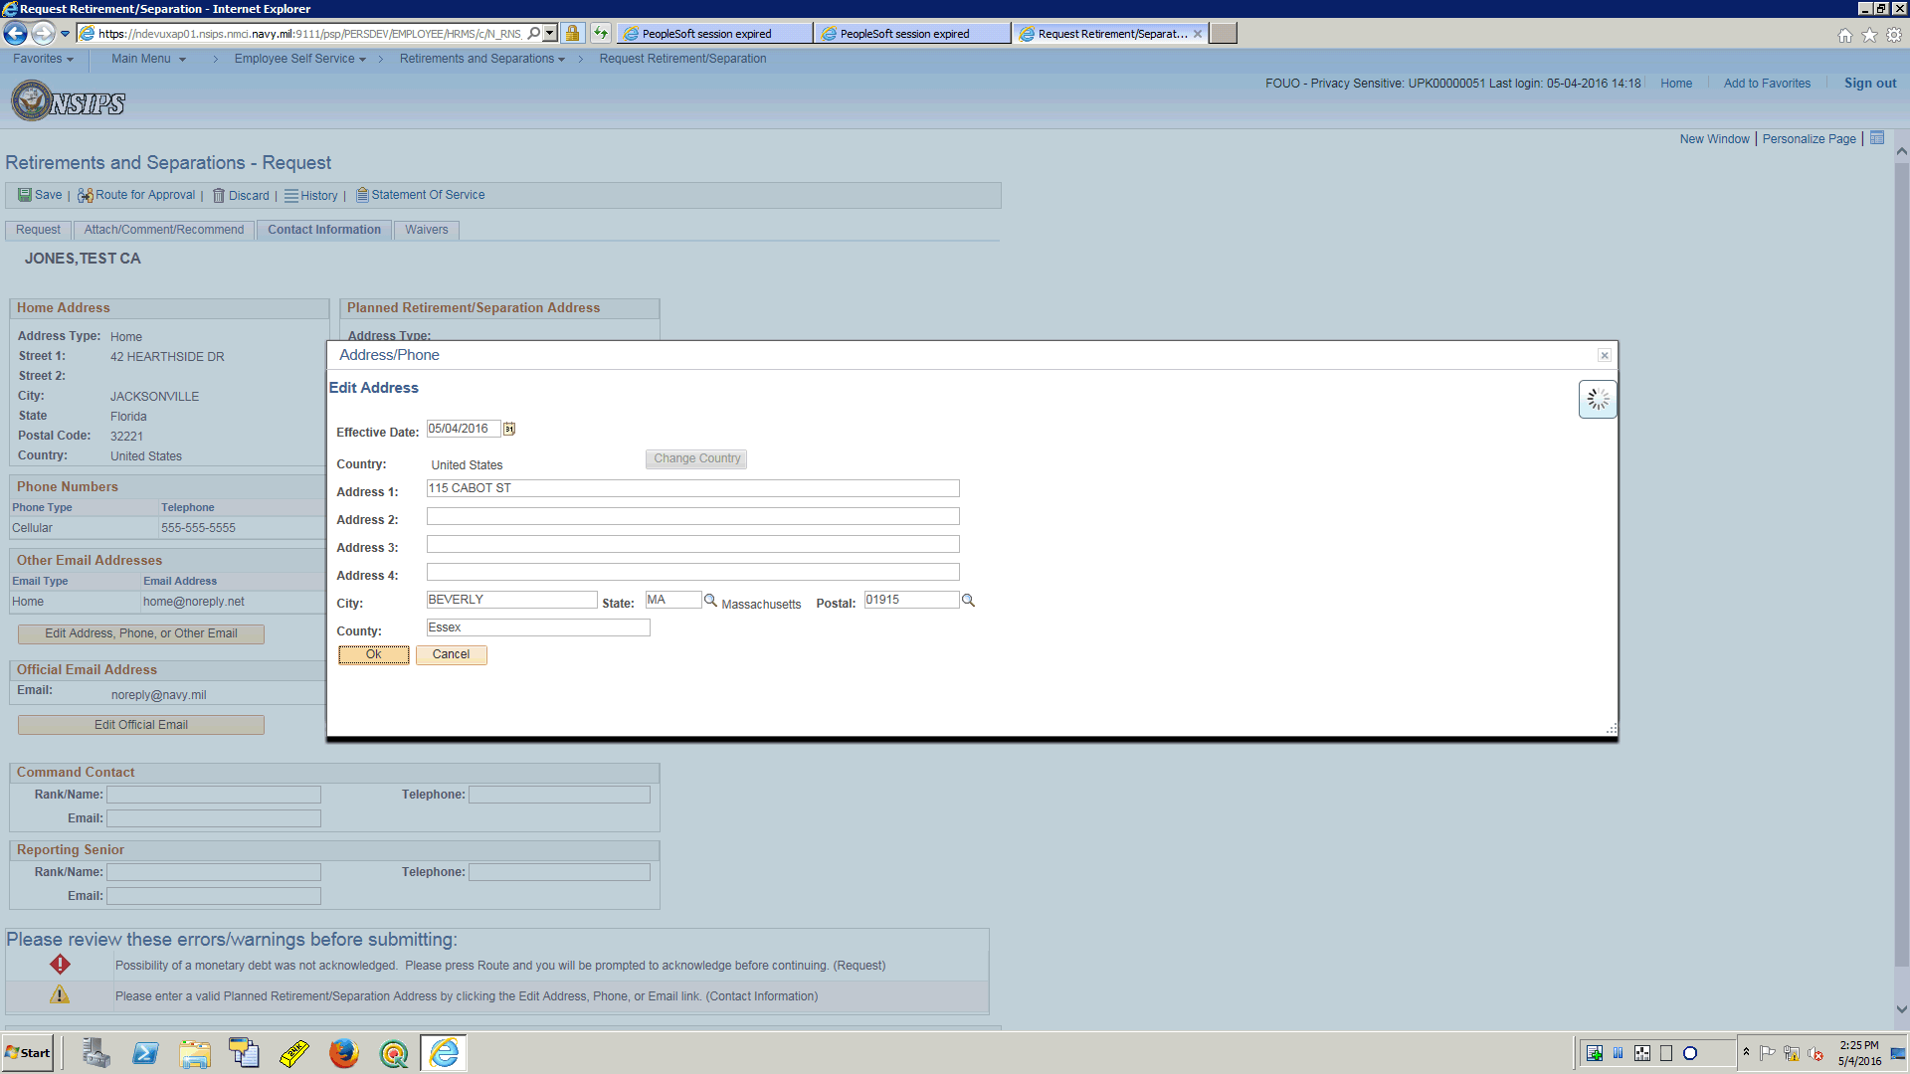

| **Step** | **Action** |
| --- | --- |
|  | Physical address data entry is complete.  Select OK  Click the **Ok** button. |

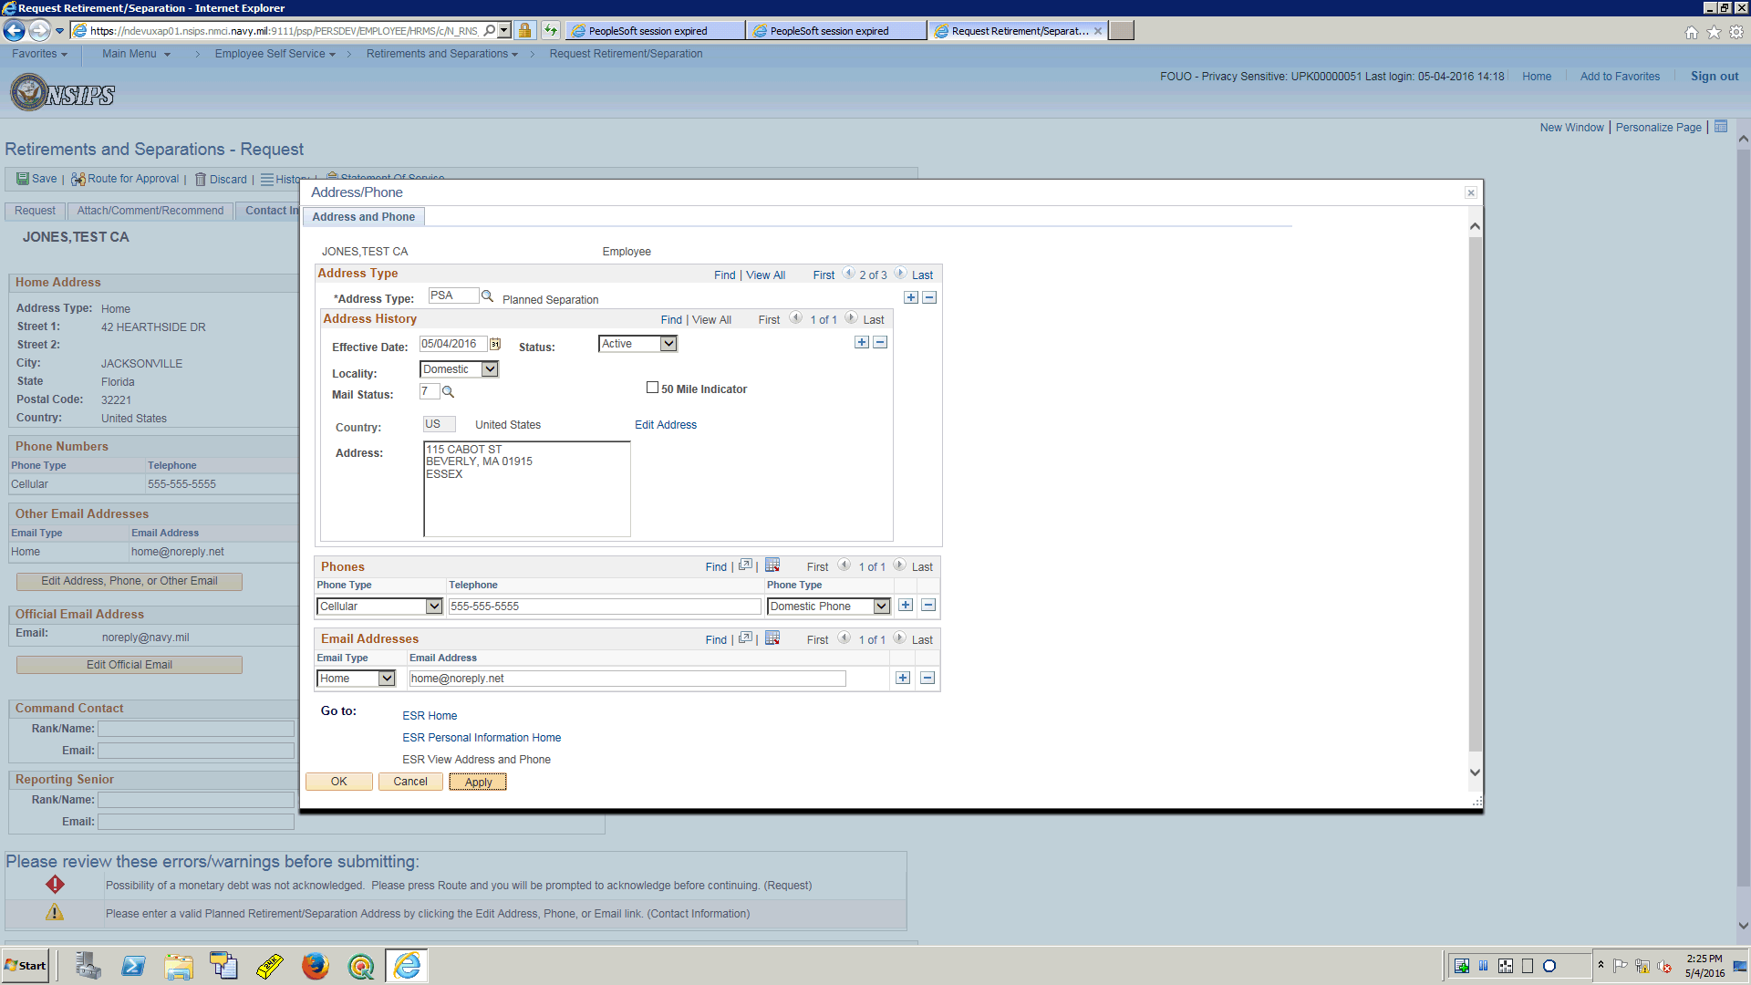

| **Step** | **Action** |
| --- | --- |
|  | Update of the Address/Phone is complete.  Click the **Apply** button. |

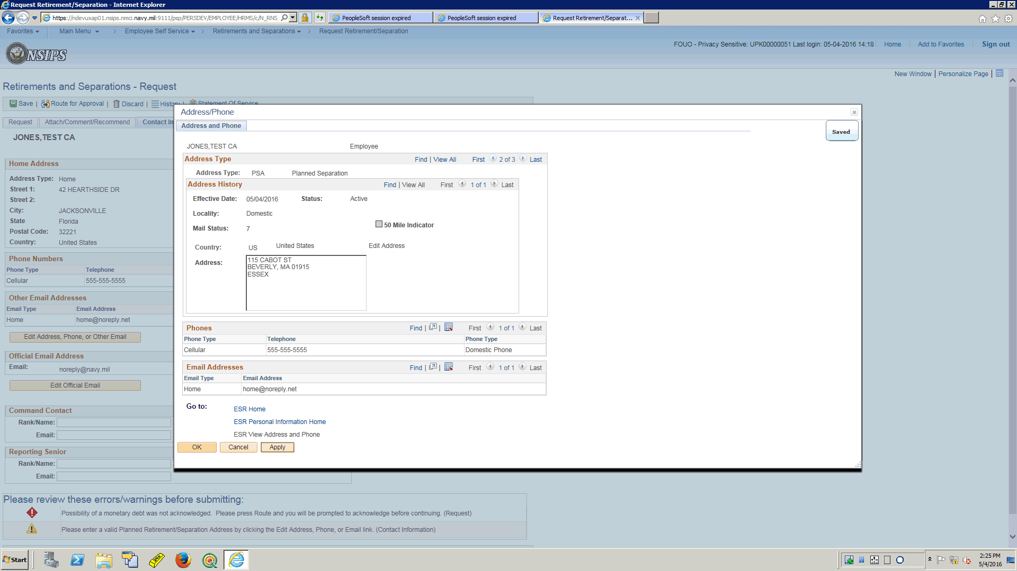

| **Step** | **Action** |
| --- | --- |
|  | Click the **OK** button. |

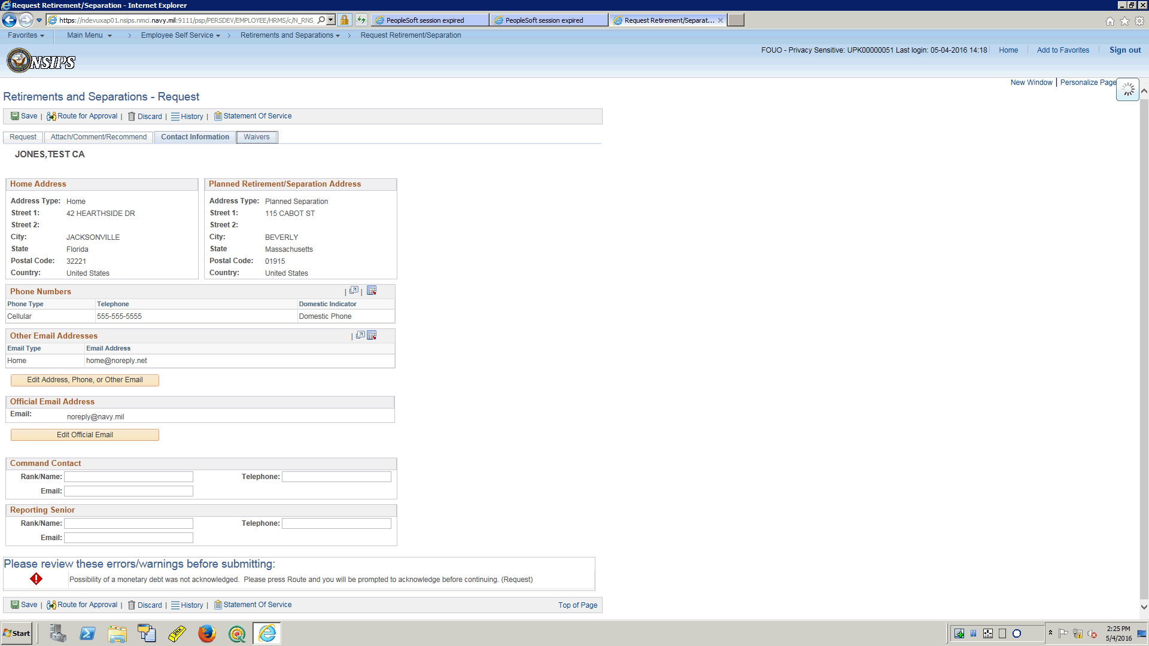

| **Step** | **Action** |
| --- | --- |
|  | Selct the waivers tab to verify all data entries present.  Click the **Waivers** link. |

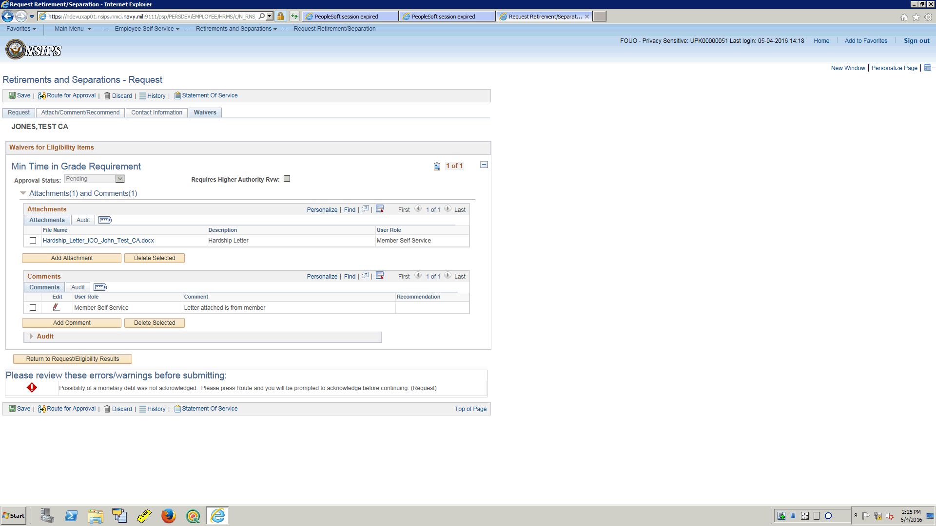

| **Step** | **Action** |
| --- | --- |
|  | All data entries by member present.  There is one error left to be cleared and it states that upon Routing the request the member will be promted to acknowledge.  Select the Request tab to complete the request process.  Click the **Request** link. |

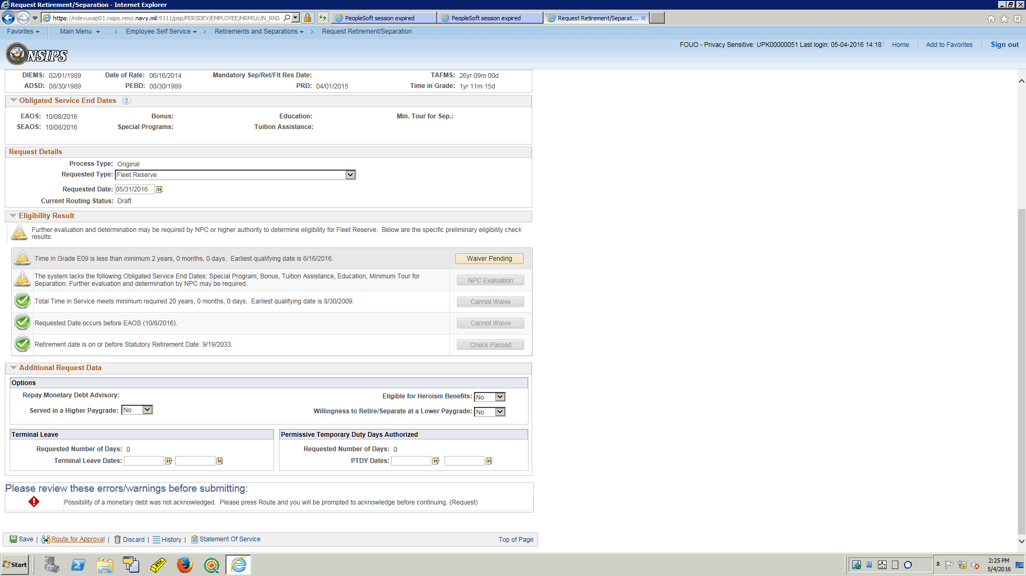

| **Step** | **Action** |
| --- | --- |
|  | The Service member has completed the process of filling out the request and it is time to Route for approval.  Knowing there is one more warning to mitigate relating to potential monetary debt incurred by the Service member.  If a Service Member has a monetary debt, it is at this point that they can submit a waiver of that debt with their request.  For this training topic there is no debt, so no waiver required.  Click the **Route for Approval** link. |

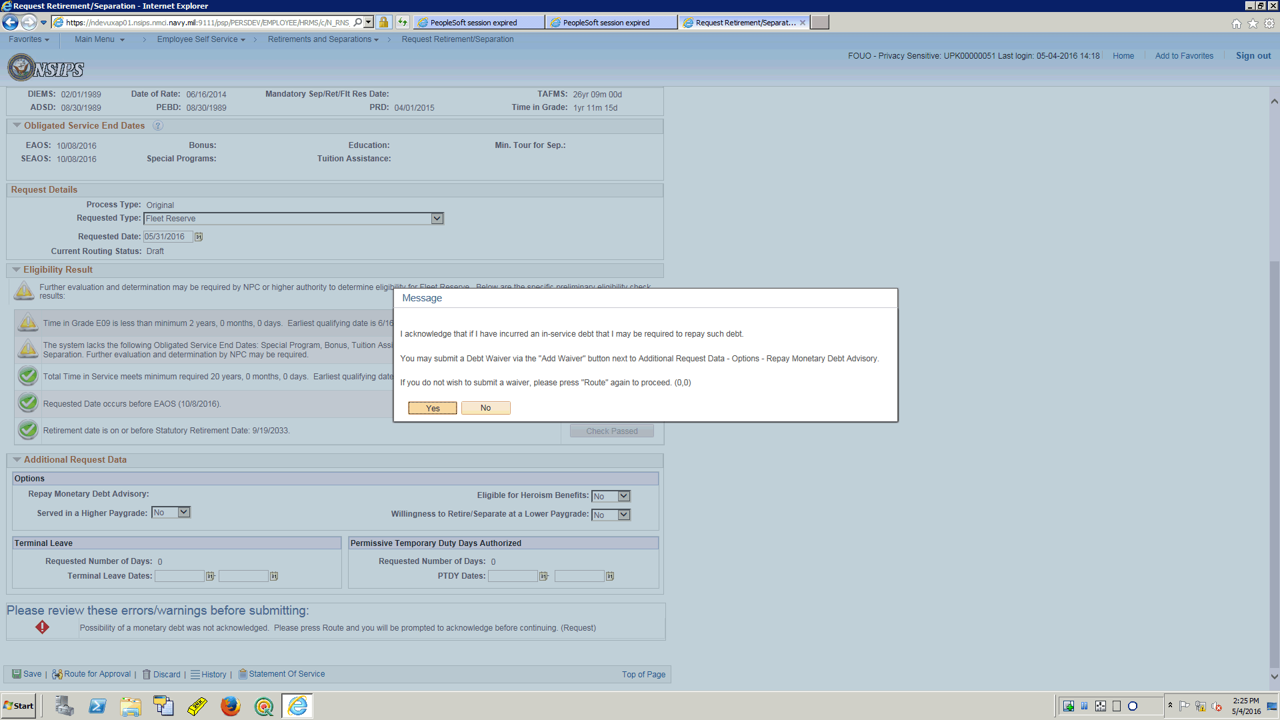

| **Step** | **Action** |
| --- | --- |
|  | Clicking yes to this message just means you are acknowledging the message.  From here you can either proceed to select to add a waiver to the request, or you can select to route the request without any waiver.  No debt incurred, no waiver required, select to route.  Click the button. |

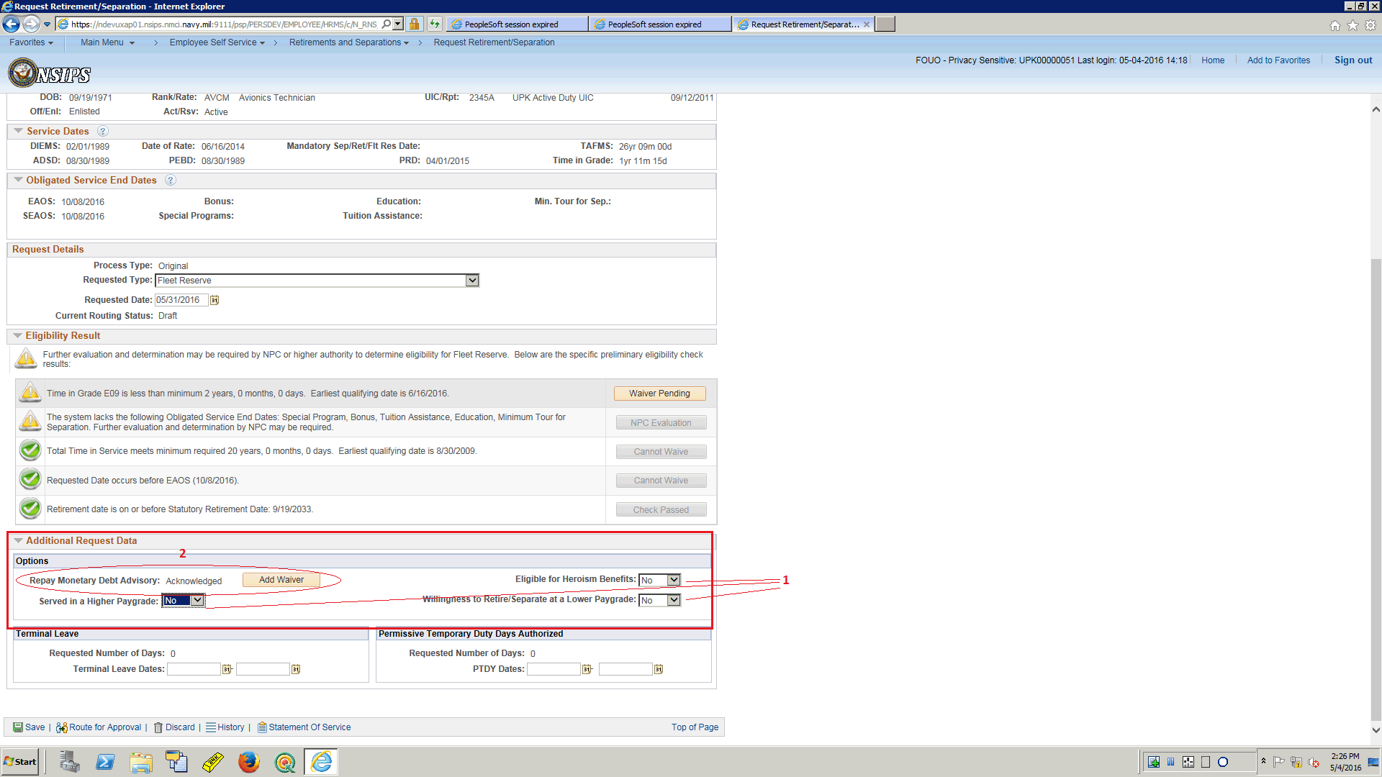

| **Step** | **Action** |
| --- | --- |
|  | 1.  There are some additional request data fields.  They are defaulted to No but it each service member should ensure they validate these are correct for them.  2.  This is also where the link to select to add a waiver to the request in the case a Service member may have Manetary Debt they wish to request waiver consideration for. |

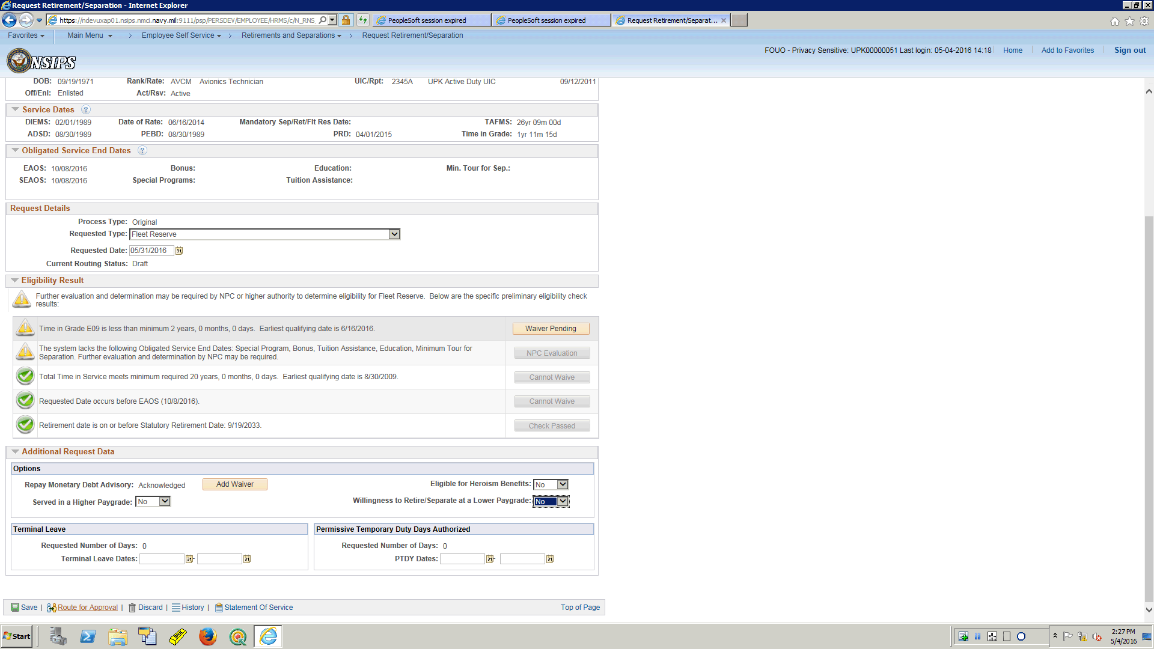

| **Step** | **Action** |
| --- | --- |
|  | Next select Route for approval.  Click the **Route for Approval** link. |

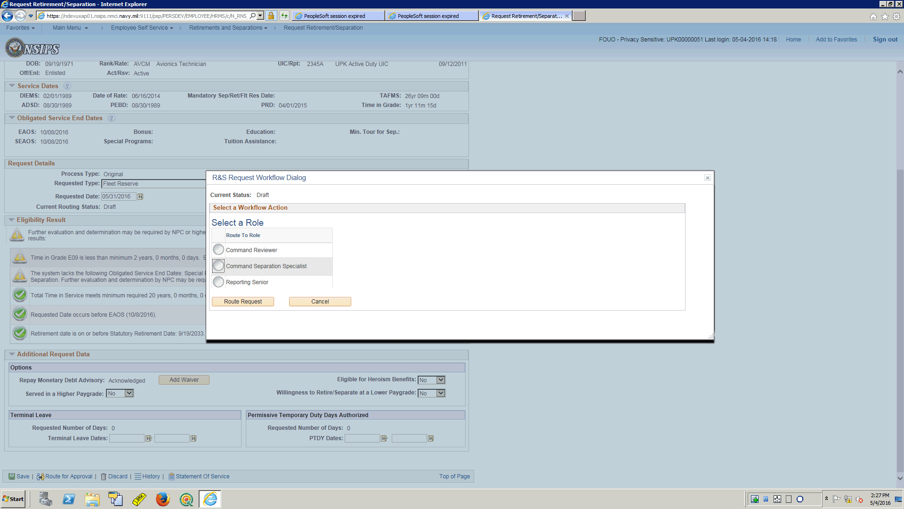

| **Step** | **Action** |
| --- | --- |
|  | Select the Command Separation Specialist.  Click the **Select** button. |

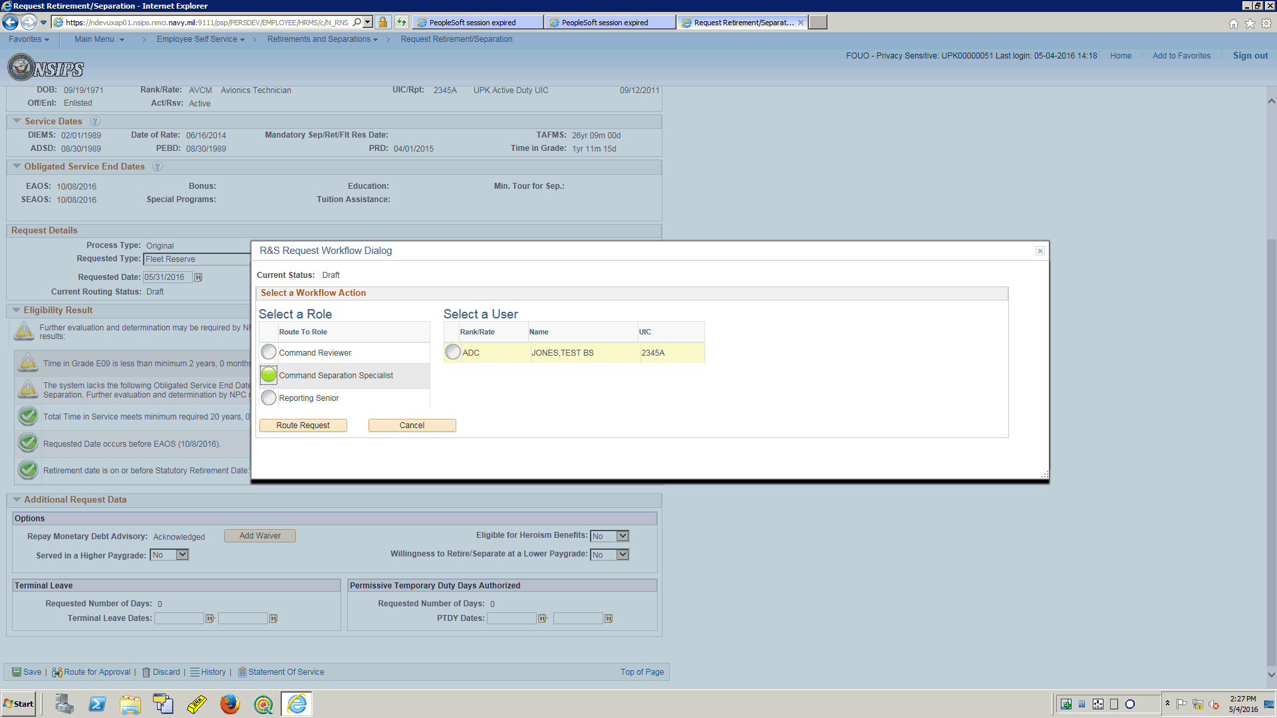

| **Step** | **Action** |
| --- | --- |
|  | Once a role is selected for the request to be routed to, the application will provide a list of Separation Specialists within the Command to choose for routing.  For this training topic we only have one to choose from, select ADC.  Click the **Select** button. |

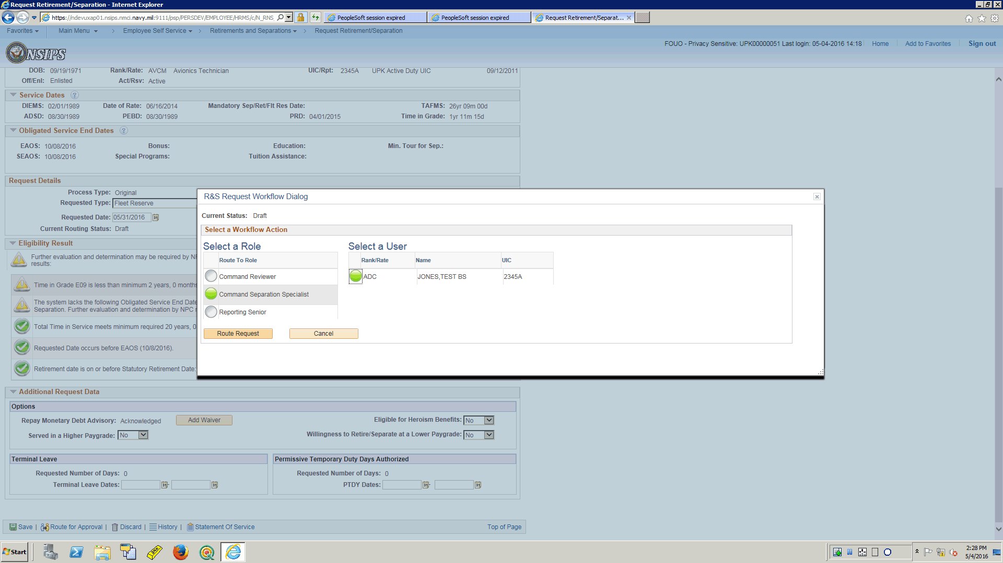

| **Step** | **Action** |
| --- | --- |
|  | The Service Member has completed the process.  Click the **Route Request** button. |

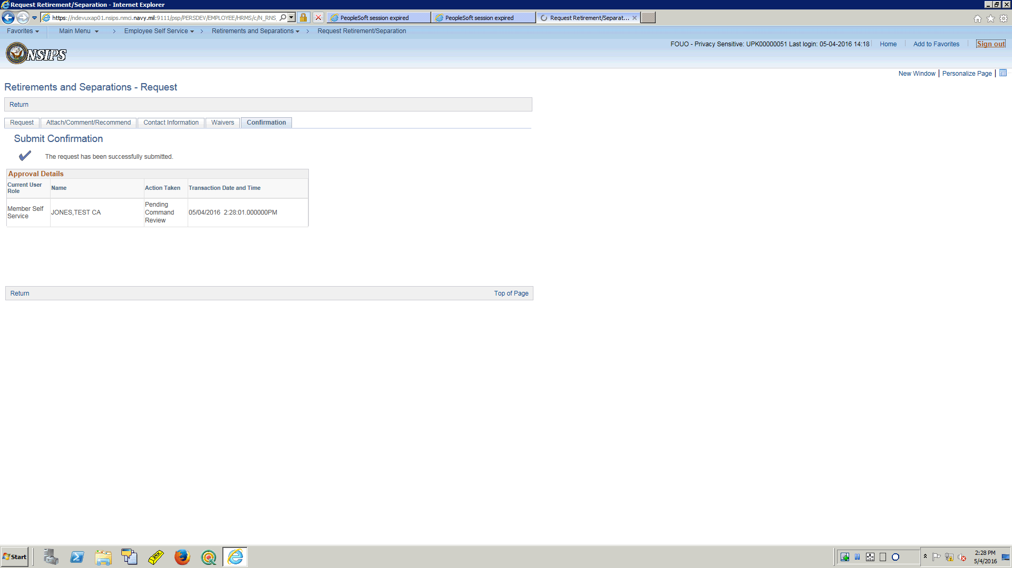

| **Step** | **Action** |
| --- | --- |
|  | Now that the submission confirmation has been displayed, an email will go to the Command Separation Specialist making them aware that there is a request pending action by them.  The Service Member can sign out  Click the **Sign out** link. |

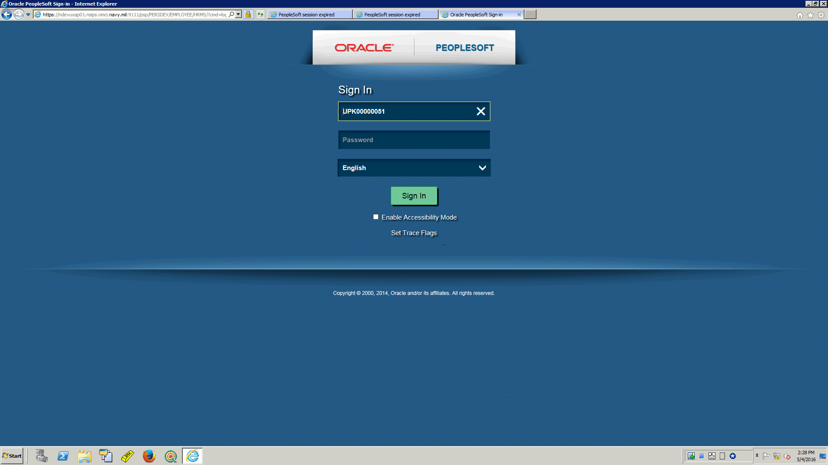

| **Step** | **Action** |
| --- | --- |
|  | This training topic showed the process a member used to submit a Regular Request using the Retirements/Separations Component.  **End of Procedure.** |